Community United Reformed Church

January 7, 2018

WELCOME TO COMMUNITY!

We're glad that you're here with us today. Please join us for a time of fellowship after the service. If you're new here and have questions, speak with our pastor, one of our greeter volunteers, and/or fill out a visitor's card, located on the Visitors’ Kiosk, to help us get to know you. May God bless our worship and life together.

LARGE PRINT BULLETINS ARE AVAILABLE
ON THE VISITORS’ KIOSK OR YOU MAY ASK AN USHER

TODAY
9:30 AM Morning Worship Service
11:00 AM Community Groups Meeting*
5:00 PM Evening Catechism Service

WELCOME: During our morning worship service we welcome Susan Kloosterman as a member of our congregation. Sue’s membership was received from the Lincoln Square Presbyterian Church (PCA). May the Lord bless Sue in her new church home.

SUNDAY SCHOOL AND CATECHISM CLASSES will not meet today due to the Christmas/New Year break (December 24, 31 and January 7). The second half of the church education year will begin, the Lord willing, on January 14.

COMMUNITY GROUPS: A meeting is scheduled for those who have signed up to participate in the Community Groups program. It will be held in the Adult Sunday School room after the morning service and we will be discussing the details of group organization and group assignments.

THIS WEEK
Monday 7:30 PM Men’s Society*
Tuesday 9:30 AM Women’s Morning Bible Study & Little Lambs
Lesson 6, pages 139-143, answer all questions
Snacks: Erica Dykshorn
Wednesday 7:00 PM Cadet Meeting
GEMS Meeting
Women’s Evening Bible Study
Lesson 5
Friday 7:00-9:00 PM Cadet Christmas Party*
(at Crown Point Christian School)
Saturday 8:00 AM Men’s Forum

FUTURE EVENTS
March 10 7:00 AM-11:00 AM Community Pancake Breakfast*
April 17-28 Men’s Retreat at Gull Lake, Michigan*

*See announcements for details

ANNOUNCEMENTS
THANK YOU: Craig, Mari, and Connor Zandstra would like to sincerely thank the CURC congregation for the many prayers, thoughts, phone calls, messages, cards, gifts, visits, and meals since Grant was born in 2006. We are truly blessed to be part of God's family.

THANK YOU: I want to thank all my church family that came to Bethshan to sing Christmas carols .... it was so nice .... we had a great time eating at Portillo's too! —Beth Zandstra

THANK YOU: I would like to thank the congregation for all the wonderful cards, gifts and goodies I received during the holiday season and through the year. It is a blessing to be a part of your church family! —Linda Vegter

ADULT SUNDAY SCHOOL: Starting January 14, we will be offering a class after the morning service called "Christianity Explored." This class is accessible for people encountering the Christian faith for the first time and is equally beneficial for lifelong Christians to rediscover the message of Jesus. We'll be seeking to answer basic questions in a warm, friendly environment. This is a great opportunity to invite friends and neighbors to explore Christianity with us for the next few months. This class will be the first of a set of six classes called "Spiritual Foundations" that will be offered for the next three years. These classes will build on each other, working from the basics of faith through layers of Christian theology, mission, and practice. Come join us! Sign-up on the Visitors Kiosk or the Members Table.

ADVENT & CHRISTMAS SONGBOOK: If anyone would like a copy (or several) of the Advent & Christmas Songbooks that were in the Psalter Hymnal during the month of December, please help yourself to them. They are located on the table in the narthex.

CADET CHRISTMAS PARTY will be held on January 12 from 6-9 pm at Crown Point Christian School gym. Come hungry and ready for a fun night!

CLASSIS MEETING: Faith URC in Beecher is hosting the next meeting of our Classis (Classis is the regional body of other URCNA churches with whom we enjoy close fellowship). Our Classis will be meeting jointly with the local Presbytery of the OPC (the Orthodox Presbyterian Church, a Reformed denomination from the British tradition with whom we share close ties. The closest OPC churches to us are in Orland Park and New Lennox). Because of the size of these two bodies, it was decided that our church building is better suited to host this meeting. So we are looking for volunteers to help organize meals and refreshments for this March 15-17 meeting. We will need bakers, servers, and organizers. These volunteers will be working with other volunteers from Faith URC and the local OPC churches. If you are willing to help in this, please speak to Pastor Oord or Dan Zandstra.

COURIER: The deadline for the next issue is January 14. Articles may be placed in the Courier mailbox in the office or they may be emailed to the church at curcoffice@sbcglobal.net. Any interesting news items and photos of the congregation would be appreciated.

DAILY PRAYER REMINDERS for the month of January are in your mailbox and on the Visitors’ Kiosk.

FOOD & DIAPER DRIVE: We continue to collect items for the Food and Diaper table during the entire year. Please bring in your donated items to support the Beacon Light food bank and the Women's Center.

INSTALLATION: Rev. Jeff De Boer will be officially installed as our associate pastor on Sunday, February 4, as part of our morning service. We are thankful for the work he has been doing here and at Mid-America Reformed Seminary and look forward to seeing God continuing to use him here in Northwest Indiana.

MEN’S RETREAT: Save the date for a Men’s Retreat, April, 27-28, 2018 at Gull Lake, Michigan! Watch the bulletin for more details soon.

MEN'S SOCIETY will be meeting on Monday a 7:30 to complete our study of Chapter 5 concerning "The creation of all things." We will be focusing on the study questions at the end of the chapter.

THE NEARER TO GOD DEVOTIONALS for January and February are available on the kiosk.

SAVE THE DATE! Our church will be holding a "Community Pancake Breakfast" on March 10, from 7–11 am, here at church. All are welcome! This is a meaningful opportunity to encourage fellowship, not just together as a church, but also with our neighbors here in NW Indiana. We will be inviting area police and firefighters to show special appreciation for their work. Feel free to invite friends and neighbors. More details will follow in coming weeks. Please talk to Terry Krooswyk if you have any questions.

WHEELCHAIRS are available for congregation or visitor use and are located at each entrance. If you are in need of wheelchair assistance to and from the parking lot, please contact Tim Eenigenburg.

URCNA MISSIONS – January 7, 2018
United in Prayer: Up-to-date Requests from our Missionaries.
Rev. Paul Ipema is a professor in Divine Hope Reformed Bible Seminary.
1. Pray that Divine Hope students may be equipped and encouraged to minister the gospel to other inmates within their respective prisons.
2. Pray that state leaders [governors, legislators] and Department of Corrections officials would recognize the value of faith-based prison programs like DHRBS.
3. Pray that God’s people would provide generously for the daily financial needs of Divine Hope.
SERMON NOTES January 7, 2018
Rev. James Oord 9:30 am

FOCUS ON PRAYER 2018:
TO KNOW THE LOVE

Scripture Reading: Psalm 116:5-9 (p. 511); Ephesians 3:14-21 (p. 977)
Sermon Text: Ephesians 3:14-21 (p. 977)

SERMON NOTES January 7, 2018
Rev. James Oord 5:00 pm

BELGIC CONFESSION:
THOSE WHOM HE FOREKNEW

Scripture Reading: Romans 8 (p. 944)
Sermon Text: Belgic Confession, Article 16 (p. 77)

Before the Throne of God Above
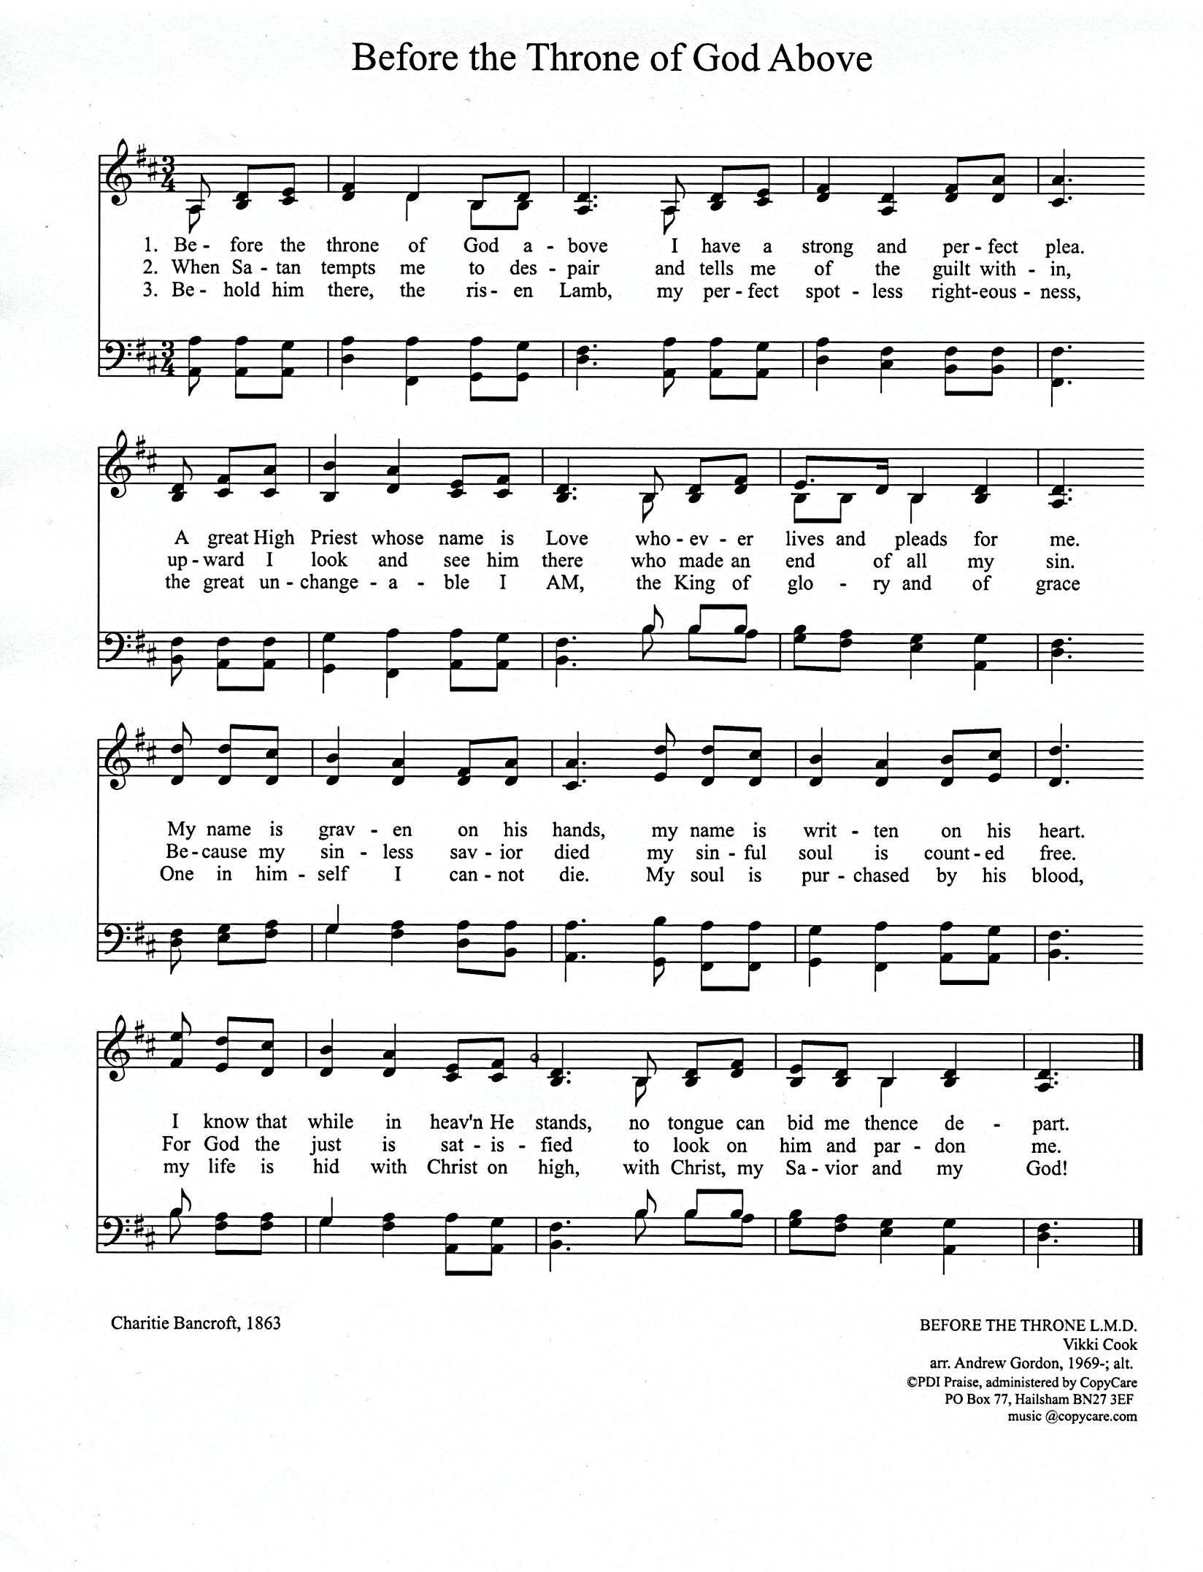

Charitie Bancroft, 1863 BEFORE THE THRONE L.M.D.
CCLI#1086929 Vikki Cook
Arr. Andrew Gordon, 1969-; alt.
PDI Praise, administered by Copy Care
PO Box 77, Hailsham BN27 3EF
music @copycare.com
Be Thou My Vision
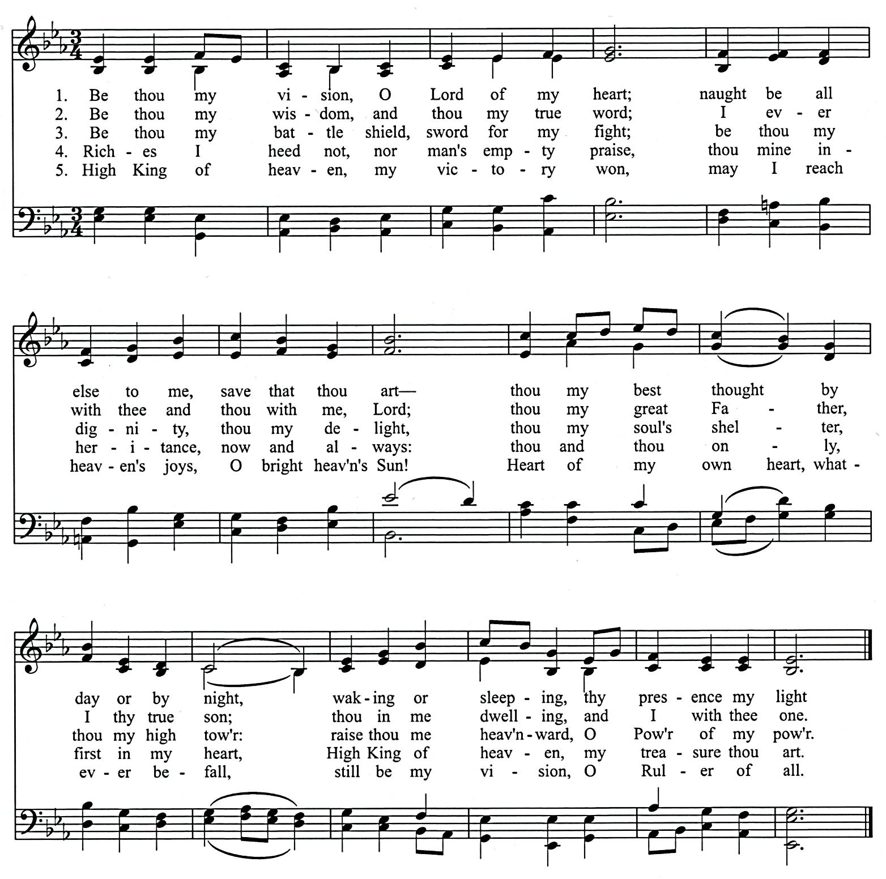

Ancient Irish poem, ca. 8th cent. SLANE 10.10.1010.
Tr. By Mary E. Bryne, 1905 Traditional Irish melody
Versified by Eleanor H. Hull, 1912
(from the Trinity Psalter Hymnal of the URCNA and OPC)
CCLI# 1086929
SCHEDULES

SERVING SUNDAY – JANUARY 7, 2018
 |  |  | AM | PM
COOKIES |  |  | Christie Eenigenburg, Kathy Eenigenburg,  Lois Eenigenburg & Lori Eenigenburg
COFFEE |  |  | Steve& Alison VanderWoude
GREETERS |  |  | Howie & Karen Hoekstra  Steve & Alison VanderWoude | Kurt & Laura Bultema  Bill & Alvina DeBoer
 | FLOATER |  | Jordan & Jess Hoekstra
LIBRARY |  |  | Barb & Beth Zandstra | Judy DeBoer
NURSERY |  | INFANT | Jennifer Bultema | Danielle Bultema
 |  | FLOATER | Kelly Aardsma
 |  | TODDLER | Susan Colvin, Jacob & Jayce Bultema | Taytum Bultema
USHERS |  |  | Elias Martin, Gabe Martin, Ian Martin, Joe Martin, Titus Martin | Bob Huizenga, Carl Huizenga, Devin Terpstra, Ryan Terpstra
WELCOME WAGON |  |  | Steve & Alison VanderWoude

SERVING SUNDAY – JANUARY 14, 2018
 |  |  | AM | PM
COOKIES |  |  | Sandi Eenigenburg, Tabitha Eenigenburg,  Ashley Frederick & Pam Hart
COFFEE |  |  | Steve& Alison VanderWoude
GREETERS |  |  | Dave Bakker  Ross & Alexis VanDerNoord | Grace Terpstra  Gerry & Sandi Swets
 | FLOATER |  | Karen Zandstra | Derek & Jennie Terpstra
LIBRARY |  |  | Jennifer Bultema | Laurie Mitchell
NURSERY |  | INFANT | Sandi Eenigenburg | Krystle Eenigenburg
 |  | FLOATER | Anna DeBoer
 |  | TODDLER | Caitlin DeBoer & Jorie Rottier | Kathy & Brandon DeYoung
USHERS |  |  | Elias Martin, Gabe Martin, Ian Martin, Joe Martin, Titus Martin | Bob Huizenga, Carl Huizenga, Devin Terpstra, Ryan Terpstra
WELCOME WAGON |  |  | Derek & Jennie Terpstra

JANUARY 2018 GIVING SCHEDULE
 | AM | PM
1/07/2018 | Women’s Center of NWI | Messiah’s Reformed Fellowship – Rev. Murphy
1/14/2018 | Divine Hope Bible Seminary | New Horizon / Rev. Persaud
1/21/2018 | Chiesa Evangelica Riformata ‘Filadelfia’ (CERF) / Rev. Ferrari | Biblical Counseling Center
1/28/2018 | EL Pacto de Gracia (Covenant of Grace) / Rev. Ruben Sernas | Illiana Right to Life

CURC GIVING – December 24 – 31, 2017
General Fund | $ 28,980.00
Benevolence Fund | $ 4,330.00
Ceap Fund | $ 4,120.00
Missions: Elim Christian School; Crown Point Christian School; Word and Deed; Highland Christian School; DeMotte Christian School | $ 14,770

SCRIPTURE FOR THE MORNING SERVICE

PSALM 116:5-9

⁵ Gracious is the Lord, and righteous;
our God is merciful.
⁶ The Lord preserves the simple;
when I was brought low, he saved me.
⁷ Return, O my soul, to your rest;
for the Lord has dealt bountifully with you.

⁸ For you have delivered my soul from death,
my eyes from tears,
my feet from stumbling;
⁹ I will walk before the Lord
in the land of the living.

EPHESIANS 3:14-21

Prayer for Spiritual Strength
¹⁴ For this reason I bow my knees before the Father, ¹⁵ from whom every family in heaven and on earth is named, ¹⁶ that according to the riches of his glory he may grant you to be strengthened with power through his Spirit in your inner being, ¹⁷ so that Christ may dwell in your hearts through faith—that you, being rooted and grounded in love, ¹⁸ may have strength to comprehend with all the saints what is the breadth and length and height and depth, ¹⁹ and to know the love of Christ that surpasses knowledge, that you may be filled with all the fullness of God.
²⁰ Now to him who is able to do far more abundantly than all that we ask or think, according to the power at work within us, ²¹ to him be glory in the church and in Christ Jesus throughout all generations, forever and ever. Amen.

SCRIPTURE FOR THE EVENING SERVICE

PSALM 141

Give Ear to My Voice

A PSALM OF DAVID.
141 O Lord, I call upon you; hasten to me!
Give ear to my voice when I call to you!
² Let my prayer be counted as incense before you,
and the lifting up of my hands as the evening sacrifice!

³ Set a guard, O Lord, over my mouth;
keep watch over the door of my lips!
⁴ Do not let my heart incline to any evil,
to busy myself with wicked deeds
in company with men who work iniquity,
and let me not eat of their delicacies!

⁵ Let a righteous man strike me—it is a kindness;
let him rebuke me—it is oil for my head;
let my head not refuse it.
Yet my prayer is continually against their evil deeds.
⁶ When their judges are thrown over the cliff,
then they shall hear my words, for they are pleasant.
⁷ As when one plows and breaks up the earth,
so shall our bones be scattered at the mouth of Sheol.

⁸ But my eyes are toward you, O God, my Lord;
in you I seek refuge; leave me not defenseless!
⁹ Keep me from the trap that they have laid for me
and from the snares of evildoers!
¹⁰ Let the wicked fall into their own nets,
while I pass by safely.

ROMANS 8

Life in the Spirit
8 There is therefore now no condemnation for those who are in Christ Jesus. ² For the law of the Spirit of life has set you free in Christ Jesus from the law of sin and death. ³ For God has done what the law, weakened by the flesh, could not do. By sending his own Son in the likeness of sinful flesh and for sin, he condemned sin in the flesh, ⁴ in order that the righteous requirement of the law might be fulfilled in us, who walk not according to the flesh but according to the Spirit. ⁵ For those who live according to the flesh set their minds on the things of the flesh, but those who live according to the Spirit set their minds on the things of the Spirit. ⁶ For to set the mind on the flesh is death, but to set the mind on the Spirit is life and peace. ⁷ For the mind that is set on the flesh is hostile to God, for it does not submit to God's law; indeed, it cannot. ⁸ Those who are in the flesh cannot please God.
⁹ You, however, are not in the flesh but in the Spirit, if in fact the Spirit of God dwells in you. Anyone who does not have the Spirit of Christ does not belong to him. ¹⁰ But if Christ is in you, although the body is dead because of sin, the Spirit is life because of righteousness. ¹¹ If the Spirit of him who raised Jesus from the dead dwells in you, he who raised Christ Jesus from the dead will also give life to your mortal bodies through his Spirit who dwells in you.

Heirs with Christ
¹² So then, brothers, we are debtors, not to the flesh, to live according to the flesh. ¹³ For if you live according to the flesh you will die, but if by the Spirit you put to death the deeds of the body, you will live. ¹⁴ For all who are led by the Spirit of God are sons of God. ¹⁵ For you did not receive the spirit of slavery to fall back into fear, but you have received the Spirit of adoption as sons, by whom we cry, “Abba! Father!” ¹⁶ The Spirit himself bears witness with our spirit that we are children of God, ¹⁷and if children, then heirs—heirs of God and fellow heirs with Christ, provided we suffer with him in order that we may also be glorified with him.

Future Glory
¹⁸ For I consider that the sufferings of this present time are not worth comparing with the glory that is to be revealed to us. ¹⁹ For the creation waits with eager longing for the revealing of the sons of God. ²⁰ For the creation was subjected to futility, not willingly, but because of him who subjected it, in hope ²¹ that the creation itself will be set free from its bondage to corruption and obtain the freedom of the glory of the children of God. ²² For we know that the whole creation has been groaning together in the pains of childbirth until now. ²³ And not only the creation, but we ourselves, who have the firstfruits of the Spirit, groan inwardly as we wait eagerly for adoption as sons, the redemption of our bodies. ²⁴ For in this hope we were saved. Now hope that is seen is not hope. For who hopes for what he sees? ²⁵ But if we hope for what we do not see, we wait for it with patience.
²⁶ Likewise the Spirit helps us in our weakness. For we do not know what to pray for as we ought, but the Spirit himself intercedes for us with groanings too deep for words. ²⁷ And he who searches hearts knows what is the mind of the Spirit, because the Spirit intercedes for the saints according to the will of God. ²⁸ And we know that for those who love God all things work together for good, for those who are called according to his purpose. ²⁹ For those whom he foreknew he also predestined to be conformed to the image of his Son, in order that he might be the firstborn among many brothers. ³⁰ And those whom he predestined he also called, and those whom he called he also justified, and those whom he justified he also glorified.

God's Everlasting Love
³¹ What then shall we say to these things? If God is for us, who can be against us? ³² He who did not spare his own Son but gave him up for us all, how will he not also with him graciously give us all things? ³³ Who shall bring any charge against God's elect? It is God who justifies. ³⁴ Who is to condemn? Christ Jesus is the one who died—more than that, who was raised—who is at the right hand of God, who indeed is interceding for us. ³⁵ Who shall separate us from the love of Christ? Shall tribulation, or distress, or persecution, or famine, or nakedness, or danger, or sword? ³⁶ As it is written,

“For your sake we are being killed all the day long;
we are regarded as sheep to be slaughtered.”

³⁷ No, in all these things we are more than conquerors through him who loved us. ³⁸ For I am sure that neither death nor life, nor angels nor rulers, nor things present nor things to come, nor powers, ³⁹ nor height nor depth, nor anything else in all creation, will be able to separate us from the love of God in Christ Jesus our Lord.

BELGIC CONFESSION, ARTICLE 16

ETERNAL ELECTION

We believe that, all the posterity of Adam being thus fallen into perdition and ruin by the sin of our first parents, God then did manifest Himself such as He is; that is to say, merciful and just: merciful, since He delivers and preserves from this perdition all whom He in His eternal and unchangeable counsel of mere goodness has elected in Christ Jesus our Lord, without any respect to their works; just, in leaving others in the fall and perdition wherein they have involved themselves.

