Community United Reformed Church

January 14, 2018

WELCOME TO COMMUNITY!

We're glad that you're here with us today. Please join us for a time of fellowship after the service. If you're new here and have questions, speak with our pastor, one of our greeter volunteers, and/or fill out a visitor's card, located on the Visitors’ Kiosk, to help us get to know you. May God bless our worship and life together.

LARGE PRINT BULLETINS ARE AVAILABLE
ON THE VISITORS’ KIOSK OR YOU MAY ASK AN USHER

TODAY
9:30 AM Morning Worship Service
11:00 AM Sunday School & Catechism Classes
Christianity Explored Class
5:00 PM Evening Catechism Service

ADULT SUNDAY SCHOOL: Beginning today, we will be offering a class after the morning service called "Christianity Explored." This class is accessible for people encountering the Christian faith for the first time and is equally beneficial for lifelong Christians to rediscover the message of Jesus. We'll be seeking to answer basic questions in a warm, friendly environment. This is a great opportunity to invite friends and neighbors to explore Christianity with us for the next few months. This class will be the first of a set of six classes called "Spiritual Foundations" that will be offered for the next three years. These classes will build on each other, working from the basics of faith through layers of Christian theology, mission, and practice. Come join us!

THIS WEEK
Monday 7:30 PM Men’s Prayer Meeting
Tuesday 9:30 AM Women’s Morning Bible Study & Little Lambs
Lesson 7, pages 145-160, answer all questions
Snacks: Linda DeYoung
Wednesday 7:30 PM Council Meeting
Saturday 8:00 AM Men’s Forum

FUTURE EVENTS
February 23 Cadet Derby Race and Nacho Night*
March 10 7:00 AM-11:00 AM Community Pancake Breakfast*
March 15-17 Classis Meetings*
April 17-28 Men’s Retreat at Gull Lake, Michigan*

*See announcements for details

ANNOUNCEMENTS
CONTINUED PRAYER REQUESTS: DEBBIE OOMS, who is recovering from pneumonia at Community Hospital in Munster. / JOHN SUROWIEC, who was taken to the hospital with complications related to his recent surgery and is now recovering.

CHRISTIAN SYMPATHY: we express our Christian sympathy to Andy & Cecilia Rietveld, as they mourn the loss of Cecilia's sister, Nancy Piersma, who passed away on Friday, January 5. Please pray for this family as they grieve. "Jesus said to her, 'I am the resurrection and the life. Whoever believes in me, though he die, yet shall he live.'" (John 11:25)

THANK YOU: Clara Stob would like to thank the congregation for all the cards, visits, and goodies she received during the Christmas season. It is truly a blessing to belong to the family of God.

CADET DERBY RACE AND NACHO NIGHT will be held on Friday, February 23. Save the date for this fun night! more info coming soon!

CLASSIS MEETING: Faith URC in Beecher is hosting the next meeting of our Classis (Classis is the regional body of other URCNA churches with whom we enjoy close fellowship). Our Classis will be meeting jointly with the local Presbytery of the OPC (the Orthodox Presbyterian Church, a Reformed denomination from the British tradition with whom we share close ties. The closest OPC churches to us are in Orland Park and New Lennox). Because of the size of these two bodies, it was decided that our church building is better suited to host this meeting. So we are looking for volunteers to help organize meals and refreshments for this March 15-17 meeting. We will need bakers, servers, and organizers. These volunteers will be working with other volunteers from Faith URC and the local OPC churches. If you are willing to help in this, please speak to Pastor Oord or Dan Zandstra.

COMMUNITY GROUPS: Our new community groups are up and running after our organizational meeting last Sunday. Due to the enthusiastic response, we are organizing several additional groups. If you are interested in joining a group but were not able to attend our organizational meeting, please speak to Alison VanderWoude or Pastor Oord by next Sunday (January 21). May God bless our church family through the discipleship relationships established in these community groups and elsewhere.

COURIER: The deadline for the next issue is today, January 14. Articles may be placed in the Courier mailbox in the office or they may be emailed to the church at curcoffice@sbcglobal.net. Any interesting news items and photos of the congregation would be appreciated.

2018 DIRECTORY: Proof pages of the new directory are available to view in the narthex. Please check your family information and write ok by your name or write in the changes. The sheets will be available for viewing until January 28. Please call the church office and talk to Linda if you have any questions.

The DISCIPLESHIP COMMITTEE invites all parents of CURC junior high students or up and coming junior high students to a survey-type meeting to gauge interest in starting a Jr. High youth group to complement our Sr. High youth group program. The meeting will be held on Sunday, January 21 after the evening service. All parents are encouraged to attend to give their input for a beneficial discussion and question/answer time. Hope to see you there!

INSTALLATION: Rev. Jeff De Boer will be officially installed as our associate pastor on Sunday, February 4, as part of our morning service. We are thankful for the work he has been doing here and at Mid-America Reformed Seminary and look forward to seeing God continuing to use him here in Northwest Indiana.

LOST AND FOUND: We have located a number of items that belong to the congregation, including various kitchen items, a pair of children’s glasses, clothing, toys, etc. Please check out the items that are on a table located in the narthex. All items not picked up by January 28 will be brought to the thrift store.

MEN’S RETREAT: Save the date for a Men’s Retreat, April, 27-28, 2018 at Gull Lake, Michigan! Watch the bulletin for more details soon.

WHAT IF.......every member of Community United Reformed Church invited just one person to the 3rd annual Pancake Breakfast on March 10. Wouldn't that be amazing! Take advantage of this opportunity to invite your neighbor, co-worker, or friend. Who knows, this could be the beginning of a lasting relationship with CURC. Start thinking about who you are going to invite and how you might get involved in this church sponsored event. Keep watching for more details in the coming weeks!

URCNA MISSIONS – January 14, 2018
United in Prayer: Up-to-date Requests from our Missionaries.
Rev. Allen Vander Pol is a professor with MINTS International Seminary.
1. Pray that the Lord will give peace to countries where I teach and strength for the churches to endure persecution.
2. Pray that the Lord will give progress to our translation project so that we can complete it at the end of 2018.
3. Pray that I will gain the necessary skill to help direct the MINTS Online studies program.

WHAT IS CHRISTIANITY
?
It's all about one life, the life of Jesus, and it can be summed up in the answers to three questions.

Who is Jesus?
Why did Jesus come?
What does it mean for us?

We will be exploring these and other questions in our Adult Sunday School class, meeting from 11:00-11:45am on Sundays from now through May.

SERMON NOTES January 14, 2018
Rev. James Oord 9:30 am

ACTS:
RESTORING THE KINGDOM

Scripture Reading & Sermon Text: Psalm 47 (p. 472)

Introduction: why Acts, why now?

- the case (vv. 1-5)

- the question (vs. 6)

- the answer (vv. 7-8)

- the launch (vv. 9-11)

SERMON NOTES January 14, 2018
Rev. James Oord 5:00 pm

BELGIC CONFESSION:
THOSE WHOM HE FOREKNEW

Scripture Reading: Romans 8 (p. 944)
Sermon Text: Belgic Confession, Article 16 (p. 77)

Introduction: how to talk about election

- what is it?

- why does it matter?

Conclusion: how to talk about election

A Hymn of Glory Let Us Sing
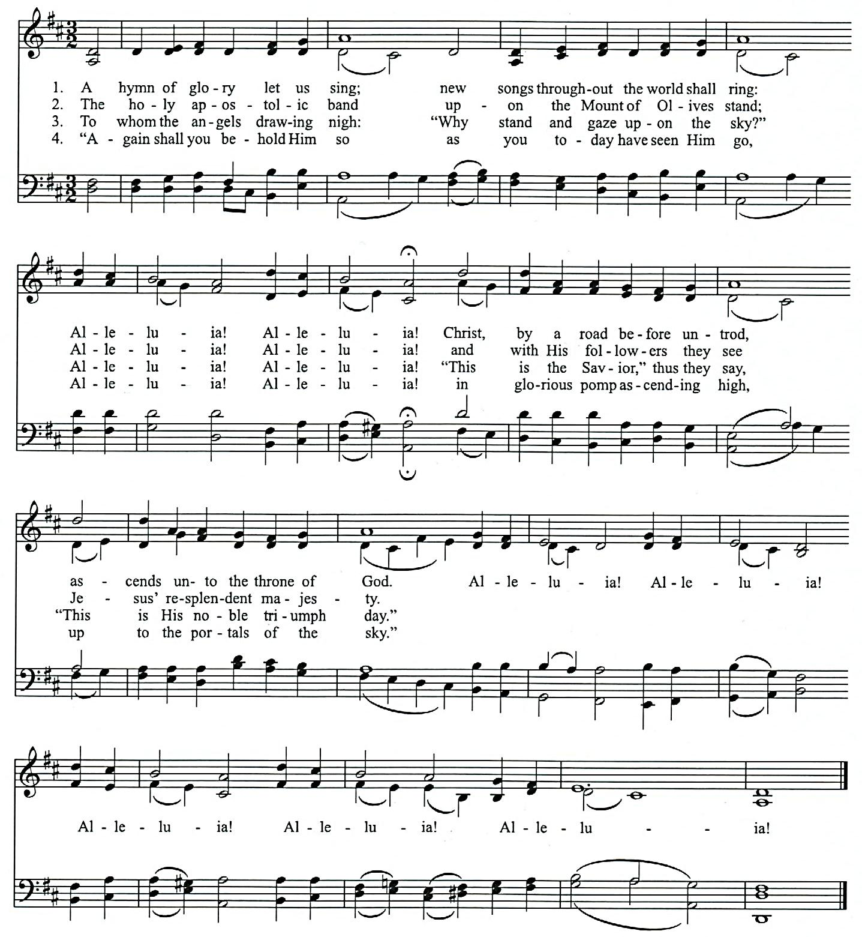

The Venerable Bede, 673-735 LASST UNS ERFREUEN LM.al.
Tr.by Benjamin Webb, 1854, alt. Geistliche Kirchensgesange, Cologne, 1623
CCLU#1086929 Tune from the English Hymnal by permission of Oxford University Press
Come, Ye Sinners, Poor and Needy
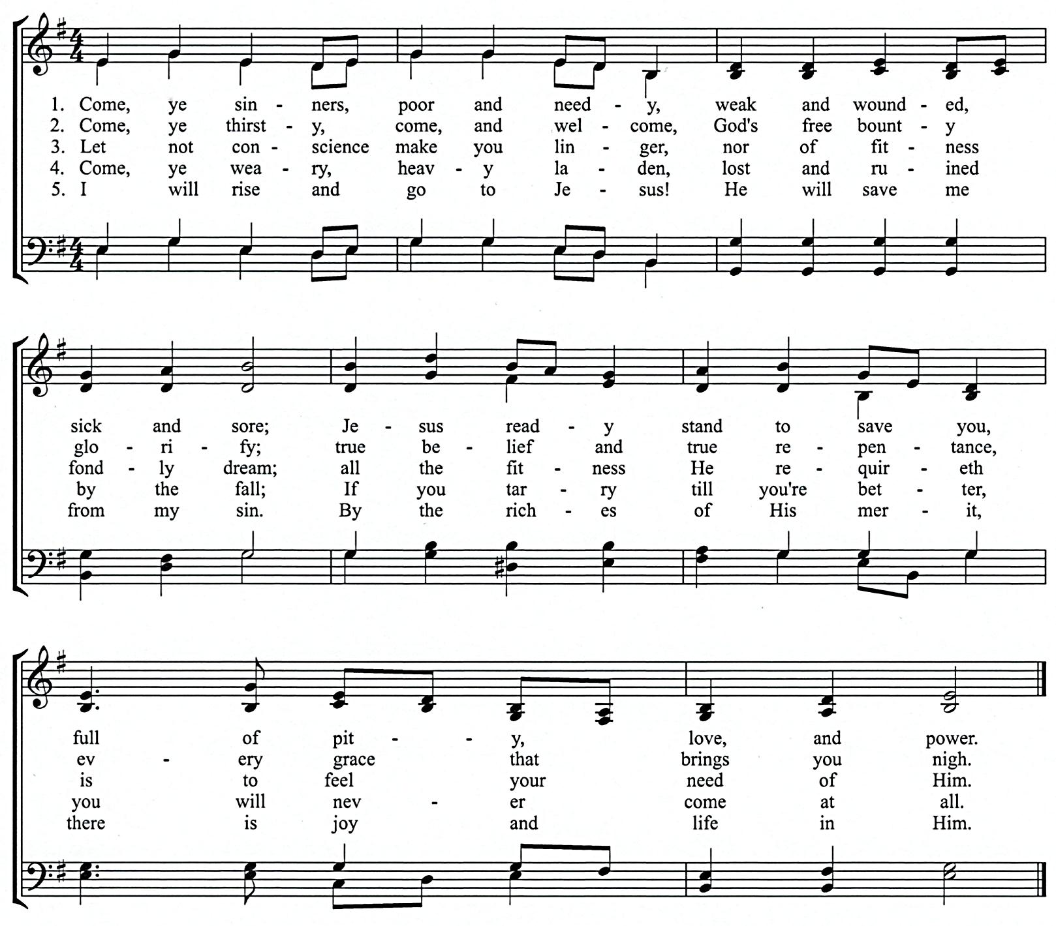

Text: Joseph Hart, alt. ARISE
Tune: traditional American melody; Walker’s Southern Harmony, 1835 8 7 8 7
CCLI#1086929
Father, Long Before Creation
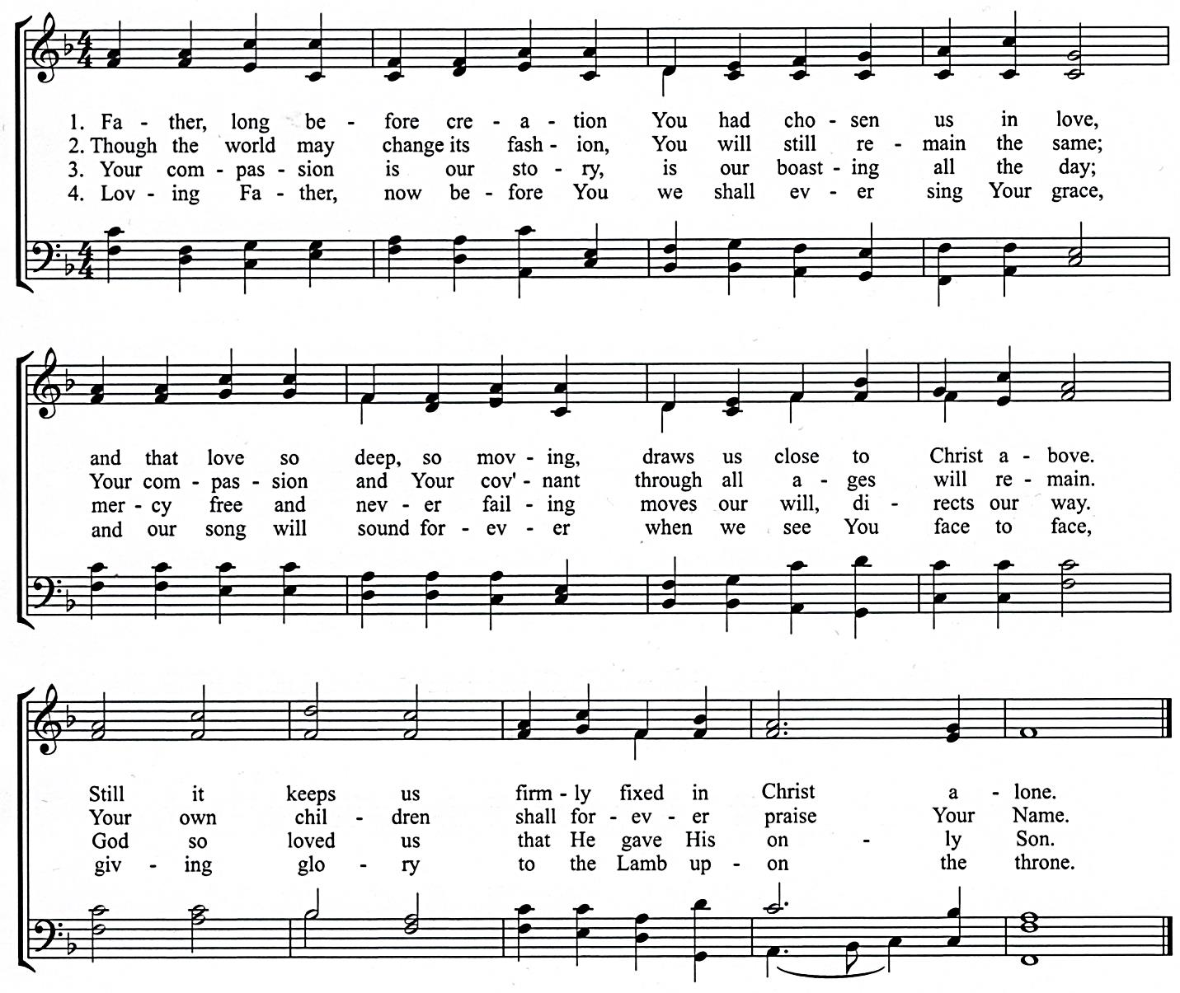

Text: Chinese c. 1952, tr. Francis P. Jones, 1953, alt. CORONAE
Tune: William H. Monk, 1871 8 7 8 7 4 7
CCLI#1086929
SCHEDULES

SERVING SUNDAY – JANUARY 14, 2018
 |  |  | AM | PM
COOKIES |  |  | Sandi Eenigenburg, Tabitha Eenigenburg,  Ashley Frederick & Pam Hart
COFFEE |  |  | Steve& Alison VanderWoude
GREETERS |  |  | Dave Bakker  Ross & Alexis VanDerNoord | Grace Terpstra  Gerry & Sandi Swets
 | FLOATER |  | Karen Zandstra | Derek & Jennie Terpstra
LIBRARY |  |  | Jennifer Bultema | Laurie Mitchell
NURSERY |  | INFANT | Sandi Eenigenburg | Krystle Eenigenburg
 |  | FLOATER | Anna DeBoer
 |  | TODDLER | Caitlin DeBoer & Jorie Rottier | Kathy & Brandon DeYoung
USHERS |  |  | Elias Martin, Gabe Martin, Ian Martin, Joe Martin, Titus Martin | Bob Huizenga, Carl Huizenga, Devin Terpstra, Ryan Terpstra
WELCOME WAGON |  |  | Derek & Jennie Terpstra

SERVING SUNDAY – JANUARY 21, 2018
 |  |  | AM | PM
COOKIES |  |  | Lorissa Haveman, Marissa Heim, Christine Hoekstra & Jess Hoekstra
COFFEE |  |  | Steve& Alison VanderWoude
GREETERS |  |  | Bryan & Debra Punter  Dan & Carol Rottier | Eric & Sarah LaReau  Scott & Vikki Ooms
 | FLOATER |  | Joseph & Linda Novosel | Dennis & Laurie Mitchell
LIBRARY |  |  | Nancy Martin | Jennie Terpstra
NURSERY |  | INFANT | Kathy & Kyle Eenigenburg | Pam Hart
 |  | FLOATER | Tabitha Eenigenburg
 |  | TODDLER | Christine & Elizabeth DeYoung | Isaac Eenigenburg & Ashley Frederick
USHERS |  |  | Elias Martin, Gabe Martin, Ian Martin, Joe Martin, Titus Martin | Bob Huizenga, Carl Huizenga, Devin Terpstra, Ryan Terpstra
WELCOME WAGON |  |  | Joe & Nancy Martin

JANUARY 2018 GIVING SCHEDULE
 | AM | PM
1/07/2018 | Women’s Center of NWI | Messiah’s Reformed Fellowship – Rev. Murphy
1/14/2018 | Divine Hope Bible Seminary | New Horizon / Rev. Persaud
1/21/2018 | Chiesa Evangelica Riformata ‘Filadelfia’ (CERF) / Rev. Ferrari | Biblical Counseling Center
1/28/2018 | EL Pacto de Gracia (Covenant of Grace) / Rev. Ruben Sernas | Illiana Right to Life

CURC GIVING – JANUARY 7, 2018
General Fund | $ 5,375.00
Benevolence Fund | $ 515.00
Ceap Fund | $ 580.00
AM: Women’s Center of NWI | $ 210.00
PM: Messiah’s Reformed Fellowship – Rev. Murphy | $ 35.00

SCRIPTURE FOR THE MORNING SERVICE

PSALM 47

God Is King over All the Earth

TO THE CHOIRMASTER. A PSALM OF THE SONS OF KORAH.
47 Clap your hands, all peoples!
Shout to God with loud songs of joy!
² For the Lord, the Most High, is to be feared,
a great king over all the earth.
³ He subdued peoples under us,
and nations under our feet.
⁴ He chose our heritage for us,
the pride of Jacob whom he loves. Selah

⁵ God has gone up with a shout,
the Lord with the sound of a trumpet.
⁶ Sing praises to God, sing praises!
Sing praises to our King, sing praises!
⁷ For God is the King of all the earth;
sing praises with a psalm!

⁸ God reigns over the nations;
God sits on his holy throne.
⁹ The princes of the peoples gather
as the people of the God of Abraham.
For the shields of the earth belong to God;
he is highly exalted!

SCRIPTURE FOR THE EVENING SERVICE

PSALM 142

You Are My Refuge

A MASKIL OF DAVID, WHEN HE WAS IN THE CAVE. A PRAYER.
142 With my voice I cry out to the Lord;
with my voice I plead for mercy to the Lord.
² I pour out my complaint before him;
I tell my trouble before him.

³ When my spirit faints within me,
you know my way!
In the path where I walk
they have hidden a trap for me.
⁴ Look to the right and see:
there is none who takes notice of me;
no refuge remains to me;
no one cares for my soul.

⁵ I cry to you, O Lord;
I say, “You are my refuge,
my portion in the land of the living.”
⁶ Attend to my cry,
for I am brought very low!
Deliver me from my persecutors,
for they are too strong for me!
⁷ Bring me out of prison,
that I may give thanks to your name!
The righteous will surround me,
for you will deal bountifully with me.

ROMANS 8

Life in the Spirit
8 There is therefore now no condemnation for those who are in Christ Jesus. ² For the law of the Spirit of life has set you free in Christ Jesus from the law of sin and death. ³ For God has done what the law, weakened by the flesh, could not do. By sending his own Son in the likeness of sinful flesh and for sin, he condemned sin in the flesh, ⁴ in order that the righteous requirement of the law might be fulfilled in us, who walk not according to the flesh but according to the Spirit. ⁵ For those who live according to the flesh set their minds on the things of the flesh, but those who live according to the Spirit set their minds on the things of the Spirit. ⁶ For to set the mind on the flesh is death, but to set the mind on the Spirit is life and peace. ⁷ For the mind that is set on the flesh is hostile to God, for it does not submit to God's law; indeed, it cannot. ⁸ Those who are in the flesh cannot please God.
⁹ You, however, are not in the flesh but in the Spirit, if in fact the Spirit of God dwells in you. Anyone who does not have the Spirit of Christ does not belong to him. ¹⁰ But if Christ is in you, although the body is dead because of sin, the Spirit is life because of righteousness. ¹¹ If the Spirit of him who raised Jesus from the dead dwells in you, he who raised Christ Jesus from the dead will also give life to your mortal bodies through his Spirit who dwells in you.

Heirs with Christ
¹² So then, brothers, we are debtors, not to the flesh, to live according to the flesh. ¹³ For if you live according to the flesh you will die, but if by the Spirit you put to death the deeds of the body, you will live. ¹⁴ For all who are led by the Spirit of God are sons of God. ¹⁵ For you did not receive the spirit of slavery to fall back into fear, but you have received the Spirit of adoption as sons, by whom we cry, “Abba! Father!” ¹⁶ The Spirit himself bears witness with our spirit that we are children of God, ¹⁷and if children, then heirs—heirs of God and fellow heirs with Christ, provided we suffer with him in order that we may also be glorified with him.

Future Glory
¹⁸ For I consider that the sufferings of this present time are not worth comparing with the glory that is to be revealed to us. ¹⁹ For the creation waits with eager longing for the revealing of the sons of God. ²⁰ For the creation was subjected to futility, not willingly, but because of him who subjected it, in hope ²¹ that the creation itself will be set free from its bondage to corruption and obtain the freedom of the glory of the children of God. ²² For we know that the whole creation has been groaning together in the pains of childbirth until now. ²³ And not only the creation, but we ourselves, who have the firstfruits of the Spirit, groan inwardly as we wait eagerly for adoption as sons, the redemption of our bodies. ²⁴ For in this hope we were saved. Now hope that is seen is not hope. For who hopes for what he sees? ²⁵ But if we hope for what we do not see, we wait for it with patience.
²⁶ Likewise the Spirit helps us in our weakness. For we do not know what to pray for as we ought, but the Spirit himself intercedes for us with groanings too deep for words. ²⁷ And he who searches hearts knows what is the mind of the Spirit, because the Spirit intercedes for the saints according to the will of God. ²⁸ And we know that for those who love God all things work together for good, for those who are called according to his purpose. ²⁹ For those whom he foreknew he also predestined to be conformed to the image of his Son, in order that he might be the firstborn among many brothers. ³⁰ And those whom he predestined he also called, and those whom he called he also justified, and those whom he justified he also glorified.

God's Everlasting Love
³¹ What then shall we say to these things? If God is for us, who can be against us? ³² He who did not spare his own Son but gave him up for us all, how will he not also with him graciously give us all things? ³³ Who shall bring any charge against God's elect? It is God who justifies. ³⁴ Who is to condemn? Christ Jesus is the one who died—more than that, who was raised—who is at the right hand of God, who indeed is interceding for us. ³⁵ Who shall separate us from the love of Christ? Shall tribulation, or distress, or persecution, or famine, or nakedness, or danger, or sword? ³⁶ As it is written,

“For your sake we are being killed all the day long;
we are regarded as sheep to be slaughtered.”

³⁷ No, in all these things we are more than conquerors through him who loved us. ³⁸ For I am sure that neither death nor life, nor angels nor rulers, nor things present nor things to come, nor powers, ³⁹ nor height nor depth, nor anything else in all creation, will be able to separate us from the love of God in Christ Jesus our Lord.

BELGIC CONFESSION, ARTICLE 16

ETERNAL ELECTION

We believe that, all the posterity of Adam being thus fallen into perdition and ruin by the sin of our first parents, God then did manifest Himself such as He is; that is to say, merciful and just: merciful, since He delivers and preserves from this perdition all whom He in His eternal and unchangeable counsel of mere goodness has elected in Christ Jesus our Lord, without any respect to their works; just, in leaving others in the fall and perdition wherein they have involved themselves.
