Community United Reformed Church

January 21, 2018

WELCOME TO COMMUNITY!

We're glad that you're here with us today. Please join us for a time of fellowship after the service. If you're new here and have questions, speak with our pastor, one of our greeter volunteers, and/or fill out a visitor's card, located on the Visitors’ Kiosk, to help us get to know you. May God bless our worship and life together.

LARGE PRINT BULLETINS ARE AVAILABLE
ON THE VISITORS’ KIOSK OR YOU MAY ASK AN USHER

TODAY
9:30 AM Morning Worship Service
11:00 AM Sunday School & Catechism Classes
Christianity Explored Class*
4:00 PM Dyer Nursing Home*
5:00 PM Evening Catechism Service
6:30 PM Discipleship Committee Meeting with Parents*

ADULT SUNDAY SCHOOL: Beginning today, we will be offering a class after the morning service called "Christianity Explored." This class is accessible for people encountering the Christian faith for the first time and is equally beneficial for lifelong Christians to rediscover the message of Jesus. We'll be seeking to answer basic questions in a warm, friendly environment. This is a great opportunity to invite friends and neighbors to explore Christianity with us for the next few months. This class will be the first of a set of six classes called "Spiritual Foundations" that will be offered for the next three years. These classes will build on each other, working from the basics of faith through layers of Christian theology, mission, and practice. Come join us!

DYER NURSING HOME: You are invited to join us today at 4:00 pm as we visit with the residents!

The DISCIPLESHIP COMMITTEE invites all parents of CURC junior high students or up and coming junior high students to a survey-type meeting to gauge interest in starting a Jr. High youth group to complement our Sr. High youth group program. The meeting will be held on Sunday, January 21 after the evening service. All parents are encouraged to attend to give their input for a beneficial discussion and question/answer time. Hope to see you there!

THIS WEEK
Monday 7:30 PM Men’s Society
Tuesday 9:30 AM Women’s Morning Bible Study & Little Lambs
Lesson pages 165- 170, answer all questions
Snacks: Abby Jacobs
Wednesday 7:00 PM Cadet Meeting
GEMS Meeting
Women’s Evening Bible Study
Lesson 6
Saturday 8:00 AM Men’s Forum

FUTURE EVENTS
February 23 Cadet Derby Race and Nacho Night*
March 10 7:00 AM-11:00 AM Community Pancake Breakfast*
March 15-17 Classis Meetings*
April 17-28 Men’s Retreat at Gull Lake, Michigan*
June 21-24 Church Camping Trip

*See announcements for details

ANNOUNCEMENTS
CONTINUED PRAYER REQUESTS: HOWARD HOEKSTRA'S mother, Gert, who is recovering from her recent successful surgery. / KEN KUIPER'S sister, Cindy, who is dealing with the effects of Parkinson's disease. / DEBBIE OOMS, who remains at Community Hospital in Munster, going through rehab and dealing with complications from her pneumonia. / JOHN SUROWIEC, who required a further procedure and is recovering.

COMMUNION: Next week, Lord willing, we will be celebrating the sacrament of the Lord’s Supper. This is an important part of our life together as a church, a time to remember Christ’s sacrifice for us even as we look forward to the banquet that is promised us through His resurrection. This feast is a spiritual table, at which Christ communicates Himself with all His benefits to us. At the table, we enjoy Jesus together. He nourishes, strengthens, and comforts our souls by the eating of His flesh, signified by the bread; He energizes and refreshes us by the drinking of His blood, signified by the wine. We invite you to participate in the Lord’s Supper with us if you are a professing member in good standing of a Christian church. This means that 1) you have been baptized, 2) you have made a public profession of faith in Jesus Christ, and 3) you desire to live a godly life in fellowship with His church. Do you know your place in Christ? Are you known as faithful to Christ by His church? Then you too are welcome at His table. Please note: if you are unable to partake of gluten for health reasons, please speak to an elder before the service and he will provide you with a gluten-free option for bread. Please note: if you are unable to partake of wine for health reasons, the center ring of the wine tray contains cups with grape juice.

CADET DERBY RACE AND NACHO NIGHT will be held on Friday, February 23. Save the date for this fun night! more info coming soon!

CADET PIZZA FUNDRAISER: The cadets are having a Little Caesar’s frozen pizza fundraiser. We are looking for the congregation’s help to attend the 2020 cadet camporee. 100% of the profits will go to help offset the cost. Please see any cadet for details. There will also be a signup sheet on the members table by the mailboxes. The sale will run from January 24th until February 14th. Pizzas will be available for pick up February 28 from 7-9 pm at church. Please make all checks payable to Justin Bultema. See any cadet with questions.
CHURCH CAMPING TRIP: Join us for the weekend or for a day at Prophetstown State Park in West Lafayette, Indiana, June 21-24. Rev. Oord will be leading us in worship on Sunday morning at the park! Call and reserve your campsite as soon as possible as it is already filling up. Contact Jennifer Bultema to let her know that you are coming so that you can receive more information in June. Contact information (and more) for the campground is in your mailbox.

CLASSIS MEETING: Faith URC in Beecher is hosting the next meeting of our Classis (Classis is the regional body of other URCNA churches with whom we enjoy close fellowship). Our Classis will be meeting jointly with the local Presbytery of the OPC (the Orthodox Presbyterian Church, a Reformed denomination from the British tradition with whom we share close ties. The closest OPC churches to us are in Orland Park and New Lennox). Because of the size of these two bodies, it was decided that our church building is better suited to host this meeting. So we are looking for volunteers to help organize meals and refreshments for this March 15-17 meeting. We will need bakers, servers, and organizers. These volunteers will be working with other volunteers from Faith URC and the local OPC churches. If you are willing to help in this, please speak to Pastor Oord or Dan Zandstra.

COMMUNITY GROUPS: Our new community groups are up and running after our organizational meeting last Sunday. Due to the enthusiastic response, we are organizing several additional groups. If you are interested in joining a group but were not able to attend our organizational meeting, please speak to Alison VanderWoude or Pastor Oord by today. May God bless our church family through the discipleship relationships established in these community groups and elsewhere.

2018 DIRECTORY: Proof pages of the new directory are available to view in the narthex. Please check your family information and write ok by your name or write in the changes. The sheets will be available for viewing until January 28. Please call the church office and talk to Linda if you have any questions.

DO YOU REALIZE.......there are only 7 more weeks until the 3rd annual CURC Pancake Breakfast? So, I'm sure you've thought about what stranger to CURC you are going to invite by now. (Inviting your spouse does not count, even though they may be a wee bit stranger.) Have you actually extended the invitation to them? Have you thought about your role of involvement in this church sponsored event? (Eating some pancakes does not count! ) The good thing is that you have plenty of time to free up your schedule to serve a couple hours on that March 10, Saturday morning. If you have any questions or better yet, some suggestion on how to make this event even better, talk to Terry Krooswyk. He would love to hear from you.

GEMS GALENTINE’S PARTY: Our GEMS will be having a fun “gals” night at their “Gal”entine’s party on Wednesday, February 14. More information coming soon.

INSTALLATION: Rev. Jeff De Boer will be officially installed as our associate pastor on Sunday, February 4, as part of our morning service. We are thankful for the work he has been doing here and at Mid-America Reformed Seminary and look forward to seeing God continuing to use him here in Northwest Indiana.

LOST AND FOUND: We have located a number of items that belong to the congregation, including various kitchen items, a pair of children’s glasses, clothing, toys, etc. Please check out the items that are on a table located in the narthex. All items not picked up by January 28 will be brought to the thrift store.

MEN’S RETREAT: Save the date for a Men’s Retreat, April, 27-28, 2018 at Gull Lake, Michigan! Watch the bulletin for more details soon.

MEN'S SOCIETY will meet this Monday to continue our study of Calvin's Institutes. During our next few meetings we will be focusing our attention on Calvin's explanation of God's "providence." This discussion will be directed by our reflection of Chapter 6 in Piety's Wisdom by Dr. Mark Beach.

PSALM 150 PRAISE NIGHT: Next week, January 28, after the evening service, all are welcome to join in a time of fellowship and praise. We will be sharing a meal and praising God through song. We will be focusing on hymns and psalms celebrating Epiphany. If you play an instrument, bring it! Our potluck meal will be themed around Scrumptious Soup Night, Please bring a soup to Share. Bread, crackers and drink will be provided. If a few people would like to bring a dessert instead of soup, please contact Jennie Terpstra. If you have any questions, please ask Andy Anderson or Derek Terpstra.

URCNA MISSIONS – January 21, 2018
United in Prayer: Up-to-date Requests from our Missionaries.
Rev. Pablo Landazurri is a church planter in Quito, Ecuador.
1. Pray for growth in the Tumbaco preaching point. At this time we have outgrown our current place. We ask for prayer so that the Lord would preserve them and for a provision of a larger place, especially from the local college.
2. Pray for my family. My wife needs to go to the medical doctor twice a week for 3 hours each in order to receive a treatment that she needs. We are grateful for the treatment, but it is also time consuming and creates some issues with our schedule.

TODAY IS OBSERVED BY MANY CHRISTIANS IN THE UNITED STATES AS "SANCTITY OF HUMAN LIFE SUNDAY."

This observation was begun in 1984 by an official declaration by President Ronald Reagan and falls on the Sunday closest to January 22, which is the anniversary of the Roe vs. Wade decision of the Supreme Court in 1973, which guaranteed women in the United States the right to abortion. This is a day we join with our Christian brothers and sisters to renew our dedication to stand for human life, especially the vulnerable lives of children in the womb. This is also a day we are reminded to stand for all those who are vulnerable, neglected, and forgotten at any age. To be "pro-life" is to recognize that all human beings are made wonderfully in the image of God and thus must be valued, respected, and protected by those who bear Christ's Name. This includes children and their mothers, the young and the aged, the handicapped, the abused, the broken, the immigrants, the refugees, all who our society is willing to ignore and forget. The Church of Jesus Christ opens her doors in His Name as a place where there is protection and healing, forgiveness and grace, transformation and new life. If abortion has affected you or your family, if you are suffering from guilt or shame, know that there is forgiveness and transformation in Jesus. You can seek out an elder or pastor of this church for prayer and counseling, or speak to a trained counselor at the Women's Center of Northwest Indiana (219-663-5311) or Pregnancy Aid South Suburbs (PASS) (708-614-9777).

Why I Pray for an End to Sanctity of Life Day
by Russell Moore, taken from The Gospel Coalition

Each January, many churches observe “Sanctity of Human Life” Sunday, and, to be honest, I have a love/hate relationship with it.
Don’t get me wrong. It’s a joy to preach the whole counsel of God. And of course it’s not that I think Sanctity of Human Life Sunday is somehow unbiblical. No, indeed. The entire canon of Scripture is filled with God’s commitment to the fatherless and to the widow, his wrath at the shedding of innocent blood.
And I don’t think it’s inappropriate. To the contrary, just as every Lord’s Day should be Christmas, with the announcement of Jesus’s incarnation, and Easter, with the proclamation of his resurrection, so every Lord’s Day should highlight the dignity and worth of human life.
Instead, the reason I have mixed feelings about this day is that it reminds me we have to say things to one another that human beings shouldn’t have to say. Mothers shouldn’t kill their children. Fathers shouldn’t abandon their babies. No human life is worthless, regardless of skin color, age, disability, or economic status. The very fact that these things must be proclaimed is a reminder of the horrors of this present darkness. And I hate it.
But the reason why we need Sundays like this is because human dignity is a spiritual issue. It’s a spiritual issue because the gospel grounds human dignity in Jesus Christ himself. In Christ, God has forever joined deity with flesh. Jesus did not merely become human once; he is human to this day, and God’s purposes in Christ center on the humanity that bears the Creator’s divine image. To deny human dignity, then, is to deny Christ himself.
The kingdom tells us who and what matters, and this isn’t determined by strength or force of will. None of us is “viable” in ourselves alone. We may be tempted to see the vulnerable—the unborn, the aged, the poor, the diseased, the disabled, the abused, the orphaned—as “the disadvantaged,” but in the long run they are not; they are the sons and daughters whom God delights to make future rulers of the universe.
Throughout the whole gospel narrative, from Pharaoh to Herod, the enemies of God consistently carry out murderous wrath on innocents. Such attacks are not merely dramatic scenes in Scripture; they are pictures of the ongoing spiritual warfare that denigrates the value and worth of every human life—warfare that continues to this day. Moments like Sanctity of Life Sunday are reminders that the culture of death is still waging war.
That’s why it grieves me. It grieves me because it reminds me of the babies warmly nestled in wombs who may not be there tomorrow. I’m reminded there are children, maybe even blocks from my church, who’ll be slapped, punched, and burned with cigarettes before nightfall. I’m reminded there are elderly men and women languishing away in loneliness, their lives pronounced a waste.
But I also love Sanctity of Human Life Sunday when I think about the ex-orphans in our churches who have been adopted into loving families. I love it when I reflect on the men and women who serve each week in pregnancy centers for women in crisis. And I love Sanctity of Life Sunday when I see men and women who have aborted babies find their sin forgiven and washed away by Jesus Christ.
I pray regularly that for my future great grandchildren, a Sanctity of Human Life Sunday would seem as unnecessary as a Reality of Gravity Emphasis Sunday.
We’ll always need Christmas. We’ll always need Easter. But pray that someday soon, we won’t need Sanctity of Life Sunday.

SERMON NOTES January 21, 2018
Rev. James Oord 9:30 am

ACTS:
CONTINUING WITNESS
TO THE RESURRECTION

Scripture Reading: Psalm 109:1-5, 21-31(p. 508); Acts 1:12-26 (p. 909)
Sermon Text: Acts 1:12-26 (p. 909)

SERMON NOTES January 21, 2018
Rev. James Oord 5:00 pm

BELGIC CONFESSION:
SEEKING, PURSUING, RESCUING

Scripture Reading: Galatians 4:1-9 (p. 974)
Sermon Text: Belgic Confession, Article 17 (p. 77)

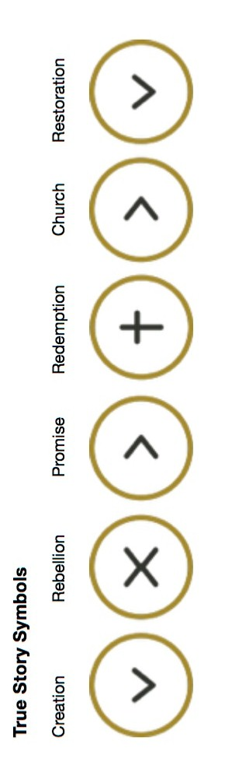

RESPONSIVE READING
FOR SANCTITY OF HUMAN LIFE SUNDAY

Leader: “Owe no one anything, except to love each other, for the one who loves another has fulfilled the law. For the commandments… are summed up in this word…” (Romans 13:8-9)

People: “You shall love the Lord your God with all your heart and with all your soul and with all your mind. This is the great and first commandment. And a second is like it: You shall love your neighbor as yourself” (Matthew 22:37-39).

Leader: “Love does no wrong to a neighbor; therefore love is the fulfilling of the law” (Romans 13:10). Love recognizes that each human being is created in the image of God:

People: “Then God said, ‘Let us make man in our image, after our likeness… So God created man in his own image, in the image of God he created him; male and female he created them” (Genesis 1:26-27).

Leader: And so love respects the life of each human being. This is the heart of the sixth commandment: “You shall not murder” (Deuteronomy 5:17). This love includes a love for the vulnerable, including those not yet born:

People: “For you formed my inward parts; you knitted me together in my mother’s womb. I praise you, for I am fearfully and wonderfully made. Wonderful are your works; my soul knows it very well” (Psalm 139:13-14)

Leader: “My frame was not hidden from you, when I was being made in secret, intricately woven in the depths of the earth” (Psalm 139:15).

People: “Your eyes saw my unformed substance; in your book were written, every one of them, the days that were formed for me, when as yet there was none of them” (Psalm 139:16).

Leader: This love includes taking a stand against violence, hatred, oppression, and murder we see around us. God says, “Rescue those who are being taken away to death; hold back those who are stumbling to slaughter” (Proverbs 24:11)

People: “If you say, ‘Behold, we did not know this,’ does not he who weighs the heart perceive it? Does not he who keeps watch over your soul know it, and will he not repay man according to his work?” (Proverbs 24:12)

Leader: “Thus says the LORD of hosts, ‘Render true judgements, show kindness and mercy to one another, do not oppress the widow, the fatherless, the sojourner, or the poor, and let none of you devise evil against another in your heart’” (Zechariah 7:9-10).

People: “He has told you, O man, what is good; and what does the LORD require of you but to do justice, and to love kindness, and to walk humbly with your God?” (Micah 6:8).

Leader: The Word of the Lord.

People: Thanks be to God.

O Church of Christ Invincible
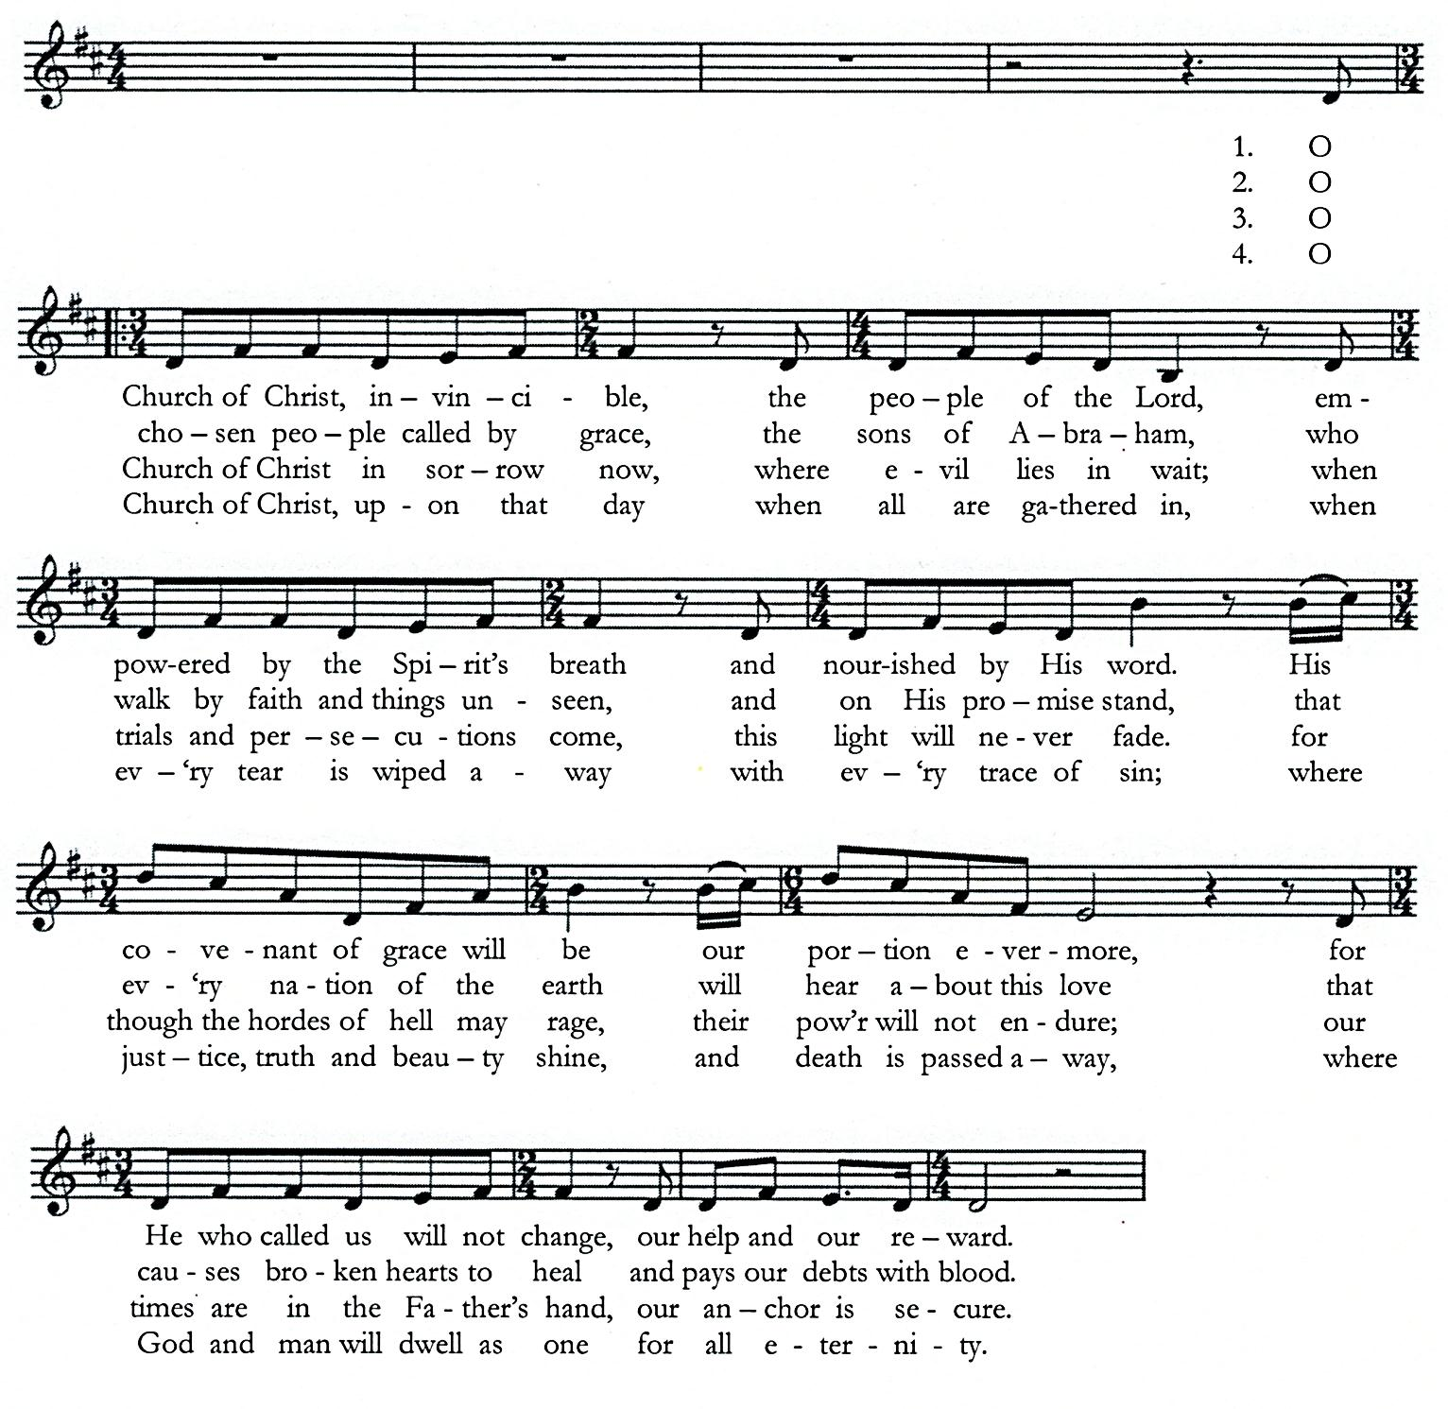

Copyright 2014 Modern Hymnal Digital/Modern Hymnal Publishing Words and Music: Matt Boswell
& Townend Songs/Adm. By Song Solutions CopyCare info@songsolutiions.org & Stuart Townend
Used by permission.
www.stuarttownend.co.uk
CCLI#1086929
By Faith
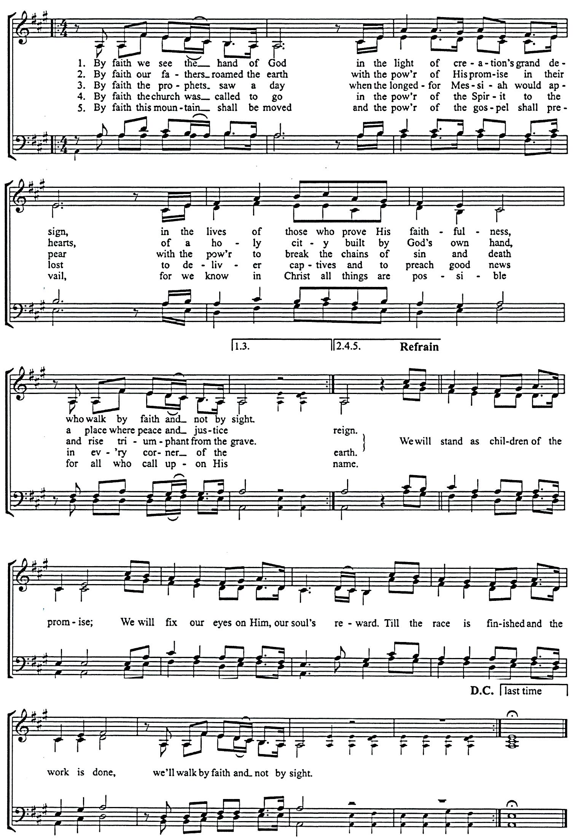

Copyright 2009 Thankyou Music/Adm. By worshiptogether.com songs & Gettymusic/Adm. By Music Services, Brentwood, TN
Excel. UK & Europe, adm. By Kingsway Music. tym@kingsway.co.uk Words and Music by
Used by permission.. Keith & Kristyn Getty
By Faith (Hymnal: Key of A) and Stuart Townend
CCLI#1086929
SCHEDULES

SERVING SUNDAY – JANUARY 21, 2018
 |  |  | AM | PM
COOKIES |  |  | Lorissa Haveman, Marissa Heim, Christine Hoekstra & Jess Hoekstra
COFFEE |  |  | Steve& Alison VanderWoude
GREETERS |  |  | Bryan & Debra Punter  Dan & Carol Rottier | Eric & Sarah LaReau  Scott & Vikki Ooms
 | FLOATER |  | Joseph & Linda Novosel | Dennis & Laurie Mitchell
LIBRARY |  |  | Nancy Martin | Jennie Terpstra
NURSERY |  | INFANT | Kathy & Kyle Eenigenburg | Pam Hart
 |  | FLOATER | Tabitha Eenigenburg
 |  | TODDLER | Christine & Elizabeth DeYoung | Isaac Eenigenburg & Ashley Frederick
USHERS |  |  | Elias Martin, Gabe Martin, Ian Martin, Joe Martin, Titus Martin | Bob Huizenga, Carl Huizenga, Devin Terpstra, Ryan Terpstra
WELCOME WAGON |  |  | Joe & Nancy Martin

SERVING SUNDAY – JANUARY 28, 2018
 |  |  | AM | PM
COOKIES |  |  | Karen Hoekstra, Carol Holderman, Kristen Huizenga & Laurie Huizenga
COFFEE |  |  | Steve& Alison VanderWoude
GREETERS |  |  | Terry & Diane Krooswyk  Mark & Lisa LaReau | Keith & Sandi Eenigenburg  Nick & Ashley Frederick
 | FLOATER |  | Howie & Karen Hoekstra | Kurt & Laura Bultema
LIBRARY |  |  | Deb DeBoer | Steve & Alison VanderWoude
NURSERY |  | INFANT | Linda DeYoung | Laurie Huizenga
 |  | FLOATER | Kristen Huizenga
 |  | TODDLER | Heather & Camille VanLaten | Abby Jacobs
USHERS |  |  | Elias Martin, Gabe Martin, Ian Martin, Joe Martin, Titus Martin | Bob Huizenga, Carl Huizenga, Devin Terpstra, Ryan Terpstra
WELCOME WAGON |  |  | District Potluck – Elder Roger Moes  (Steve & Alison VanderWoude, Tim & Lori Eenigenburg)  District Potluck – Elder Doug Terpstra  (Bill & Alvina DeBoer, Andy & Rose Anderson)

JANUARY 2018 GIVING SCHEDULE
 | AM | PM
1/07/2018 | Women’s Center of NWI | Messiah’s Reformed Fellowship / Rev. Murphy
1/14/2018 | Divine Hope Bible Seminary | New Horizon / Rev. Persaud
1/21/2018 | Chiesa Evangelica Riformata ‘Filadelfia’ (CERF) / Rev. Ferrari | Biblical Counseling Center
1/28/2018 | Benevolence | Illiana Right to Life

CURC GIVING – JANUARY 14, 2018
General Fund | $ 5,220.00
Benevolence Fund | $ 150.00
Ceap Fund | $ 220.00
AM: Divine Hope Bible Seminary | $ 646.00
PM: New Horizon / Rev. Persaud | $ 311.87

SCRIPTURE FOR THE MORNING SERVICE

PSALM 109:1-5, 21-31

Help Me, O Lord My God

TO THE CHOIRMASTER. A PSALM OF DAVID.
109 Be not silent, O God of my praise!
² For wicked and deceitful mouths are opened against me,
speaking against me with lying tongues.
³ They encircle me with words of hate,
and attack me without cause.
⁴ In return for my love they accuse me,
but I give myself to prayer.[
⁵ So they reward me evil for good,
and hatred for my love.

²¹ But you, O God my Lord,
deal on my behalf for your name's sake;
because your steadfast love is good, deliver me!
²² For I am poor and needy,
and my heart is stricken within me.
²³ I am gone like a shadow at evening;
I am shaken off like a locust.
²⁴ My knees are weak through fasting;
my body has become gaunt, with no fat.
²⁵ I am an object of scorn to my accusers;
when they see me, they wag their heads.

²⁶ Help me, O Lord my God!
Save me according to your steadfast love!
²⁷ Let them know that this is your hand;
you, O Lord, have done it!
²⁸ Let them curse, but you will bless!
They arise and are put to shame, but your servant will be glad!
²⁹ May my accusers be clothed with dishonor;
may they be wrapped in their own shame as in a cloak!

³⁰ With my mouth I will give great thanks to the Lord;
I will praise him in the midst of the throng.
³¹ For he stands at the right hand of the needy one,
to save him from those who condemn his soul to death.

ACTS 1:12-26

Matthias Chosen to Replace Judas
¹² Then they returned to Jerusalem from the mount called Olivet, which is near Jerusalem, a Sabbath day's journey away. ¹³ And when they had entered, they went up to the upper room, where they were staying, Peter and John and James and Andrew, Philip and Thomas, Bartholomew and Matthew, James the son of Alphaeus and Simon the Zealot and Judas the son of James. ¹⁴ All these with one accord were devoting themselves to prayer, together with the women and Mary the mother of Jesus, and his brothers.
¹⁵ In those days Peter stood up among the brothers (the company of persons was in all about 120) and said, ¹⁶ “Brothers, the Scripture had to be fulfilled, which the Holy Spirit spoke beforehand by the mouth of David concerning Judas, who became a guide to those who arrested Jesus. ¹⁷ For he was numbered among us and was allotted his share in this ministry.” ¹⁸ (Now this man acquired a field with the reward of his wickedness, and falling headlong he burst open in the middle and all his bowels gushed out. ¹⁹ And it became known to all the inhabitants of Jerusalem, so that the field was called in their own language Akeldama, that is, Field of Blood.) ²⁰ “For it is written in the Book of Psalms,

“‘May his camp become desolate,
and let there be no one to dwell in it’;
And

“‘Let another take his office.’

²¹ So one of the men who have accompanied us during all the time that the Lord Jesus went in and out among us, ²² beginning from the baptism of John until the day when he was taken up from us—one of these men must become with us a witness to his resurrection.” ²³ And they put forward two, Joseph called Barsabbas, who was also called Justus, and Matthias. ²⁴ And they prayed and said, “You, Lord, who know the hearts of all, show which one of these two you have chosen ²⁵ to take the place in this ministry and apostleship from which Judas turned aside to go to his own place.” ²⁶ And they cast lots for them, and the lot fell on Matthias, and he was numbered with the eleven apostles.

SCRIPTURE FOR THE EVENING SERVICE

PSALM 143

My Soul Thirsts for You

A PSALM OF DAVID.
143 Hear my prayer, O Lord;
give ear to my pleas for mercy!
In your faithfulness answer me, in your righteousness!
² Enter not into judgment with your servant,
for no one living is righteous before you.

³ For the enemy has pursued my soul;
he has crushed my life to the ground;
he has made me sit in darkness like those long dead.
⁴ Therefore my spirit faints within me;
my heart within me is appalled.

⁵ I remember the days of old;
I meditate on all that you have done;
I ponder the work of your hands.
⁶ I stretch out my hands to you;
my soul thirsts for you like a parched land. Selah

⁷ Answer me quickly, O Lord!
My spirit fails!
Hide not your face from me,
lest I be like those who go down to the pit.
⁸ Let me hear in the morning of your steadfast love,
for in you I trust.
Make me know the way I should go,
for to you I lift up my soul.

⁹ Deliver me from my enemies, O Lord!
I have fled to you for refuge.
¹⁰ Teach me to do your will,
for you are my God!
Let your good Spirit lead me
on level ground!

¹¹ For your name's sake, O Lord, preserve my life!
In your righteousness bring my soul out of trouble!
¹² And in your steadfast love you will cut off my enemies,
and you will destroy all the adversaries of my soul,
for I am your servant.

GALATIANS 4:1-9

Sons and Heirs
4 I mean that the heir, as long as he is a child, is no different from a slave, though he is the owner of everything, ² but he is under guardians and managers until the date set by his father. ³ In the same way we also, when we were children, were enslaved to the elementary principles of the world. ⁴ But when the fullness of time had come, God sent forth his Son, born of woman, born under the law, ⁵ to redeem those who were under the law, so that we might receive adoption as sons. ⁶ And because you are sons, God has sent the Spirit of his Son into our hearts, crying, “Abba! Father!” ⁷ So you are no longer a slave, but a son, and if a son, then an heir through God.

Paul's Concern for the Galatians
⁸ Formerly, when you did not know God, you were enslaved to those that by nature are not gods. ⁹ But now that you have come to know God, or rather to be known by God, how can you turn back again to the weak and worthless elementary principles of the world, whose slaves you want to be once more?

BELGIC CONFESSION, ARTICLE 17

THE RECOVERY OF FALLEN MAN

We believe that our most gracious God, in His admirable wisdom and goodness, seeing that man had thus thrown himself into physical and spiritual death and made himself wholly miserable, was pleased to seek and comfort him, when he trembling fled from His presence, promising him that He would give His Son (who would be born of a woman) to bruise the head of the serpent and to make him blessed.
