Community United Reformed Church

February 18, 2018

WELCOME TO COMMUNITY!

We're glad that you're here with us today. Please join us for a time of fellowship after the service. If you're new here and have questions, speak with our pastor, one of our greeter volunteers, and/or fill out a visitor's card, located on the Visitors’ Kiosk, to help us get to know you. May God bless our worship and life together.

LARGE PRINT BULLETINS ARE AVAILABLE
ON THE VISITORS’ KIOSK OR YOU MAY ASK AN USHER

TODAY
9:30 AM Morning Worship Service
11:00 AM Greeter Meeting*
4:00 PM Dyer Nursing Home*
5:00 PM Evening Catechism Service
6:30 PM Fusion

STAND-UP CHOIR: Our stand-up choir will be singing "At the Cross" before the service this morning to prepare our hearts for worship. If you would like to join us, we will be practicing in the Adult Sunday School room starting at 9:00am.

GREETERS ORIENTATION: If you are part of our greeter team, there will be a short orientation/training meeting in the lounge after our morning service.

SUNDAY SCHOOL AND CATECHISM CLASSES: Due to the winter break, Sunday School and Catechism will not be held today. The Lord willing, classes will resume on Sunday, February 25.

DYER NURSING HOME: You are invited to join us today at 4:00 pm as we visit with the residents!

FUSION will be meeting tonight, February 18th. Anyone post-high to 30-year-old is welcome to join us for our meeting in the fellowship hall of Oak Glen URC at 2244 Indiana Ave in Lansing, IL, following Oak Glen's service (around 6:30 pm). We will be continuing our discussion on the Lord's prayer and would love to see some new faces!

THIS WEEK
Monday 7:30 PM Men’s Society
Tuesday 9:30 AM Women’s Morning Bible Study & Little Lambs
Lesson 9, p. 217-220
Snacks: Karen Zandstra
Wednesday 1:00 PM Women’s Afternoon Bible Study
Lesson 7
Snacks: Tini DeBoer & Alvina DeBoer
7:00 PM Council Meeting
Friday Cadet Derby Race and Nacho Night*
5:30 PM Voting and Nacho’s
7:00 PM Derby Car Races
Saturday 8:00 AM Men’s Forum

FUTURE EVENTS
February 26 7:00 PM Ladies Prep Night*
March 10 7:00 AM-11:00 AM Community Pancake Breakfast*
March 16-17 Cornerstone Women’s Conference*
March 15-17 Classis Meetings*
April 27-28 Men’s Retreat at Gull Lake, Michigan*
June 21-24 Church Camping Trip*

*See announcements for details
**More information coming soon

ANNOUNCEMENTS
CONTINUING PRAYER REQUESTS: CARL LEEP, who is recovering from his recent kidney surgery. / ALEXIS VANDER NOORD, who is recovering from her recent stay in the hospital for blood clots.

CHRISTIAN SYMPATHY: We express our Christian sympathy to Karla Zandstra and her family in the loss of Karla's sister, Sharon. Pray for peace and comfort for this grieving family. "Jesus said to her, 'I am the resurrection and the life. Whoever believes in me, though he die, yet shall he live'" (John 11:25).

TRANSFER: The consistory has received the membership of Joshua Dykshorn, as well as the baptized memberships of his children Addylee, Mark, and Ethan, from Cornerstone Protestant Reformed Church. We will be welcoming the Dykshorns as members on Sunday, March 4, Lord willing.

TRANSFER: At their request, statement of memberships for Warren and Elaine Bonzelaar have been sent to the Redeemer United Reformed Church of Dyer, Indiana. May the Lord bless them in their new church home.

CADET DERBY RACE AND NACHO NIGHT: Come and support the cadets at their annual Cadet Derby Race and Nacho Night which will be held on Friday, February 23. Voting and nachos will begin at 5:30 pm and the races will be held at 7:00 pm. Everyone is invited to cheer our cadets on! Contact Justin Bultema if you have any questions.

THE CHURCH SECRETARY WILL BE OUT OF THE OFFICE from February 18 – March 2. All requests and information for misc. work, flyers, etc. that need to be distributed will be completed when she returns to the office on March 6. Please place all information in the secretary mailbox in the church office. Thank you!
CLASSIS MEETING: Faith URC in Beecher is hosting the next meeting of our Classis (Classis is the regional body of other URCNA churches with whom we enjoy close fellowship). Our Classis will be meeting jointly with the local Presbytery of the OPC (the Orthodox Presbyterian Church, a Reformed denomination from the British tradition with whom we share close ties. The closest OPC churches to us are in Orland Park and New Lennox). Because of the size of these two bodies, it was decided that our church building is better suited to host this meeting. So we are looking for volunteers to help organize meals and refreshments for this March 15-17 meeting. We will need bakers, servers, and organizers. These volunteers will be working with other volunteers from Faith URC and the local OPC churches. If you are willing to help in this, please speak to Pastor Oord or Dan Zandstra.

LADIES MEAL PREP NIGHT: Monday, February 26, 7:00pm in the CURC kitchen. Please bring an appetizer or dessert to share while we put together some frozen meals. These meals can be used to bring to family, friends, or neighbors in need of a loving meal! Please sign up on the kiosk. We need 2-3 ladies to bring a stand mixer. Any questions see Marcia Mitchell or Abby Jacobs.

MEN’S RETREAT: All men are invited to attend the Community Men’s Retreat, April, 27-28, 2018 at Gull Lake, Michigan! Building on the themes of discipleship, hospitality and mission we’ve been focusing on as a church, this overnight event will provide a relaxed setting to build friendships, enjoy times of learning and recreation, and foster greater unity as we seek to follow Christ together. Bill Boekestein, pastor of Immanuel Fellowship Church in Kalamazoo, Michigan will lead us in two sessions of teaching and discussion on the topics of male friendship and hospitality. Please consider making this event a priority as you plan your spring calendar. More details are on the flyer in your mailbox. Sign up on the member’s table. Contact Elder Derek Terpstra if you have any questions or need more information.

THE NEARER TO GOD DEVOTIONALS for March and April are available on the kiosk.

NURSERY PAGERS MISSING: The nursery is missing a few pagers. If you have accidentally taken them home with you, please return them as soon as possible! Thank you!

PANCAKE BREAKFAST FLYERS: All church members are encouraged to invite neighbors, friends, and co-workers to our Community Pancake Breakfast on March 10. Extra information flyers are available on the members table and the visitor’s kiosk. Contact Terry Krooswyk if you have any questions.

PSALM 150 PRAISE NIGHT: Next week, February 25, after the evening service, all are welcome to join in a time of fellowship and praise. We will be sharing a meal and praising God through song. We will be focusing on hymns and psalms celebrating Lent. If you play an instrument, bring it! Please bring a dish you love! It can be pink, red or heart shaped or none of the above.😉. It can be a side, main or dessert. This meal will be an adventure and full of surprises. Drinks will be provided. If you have any questions, please ask Andy Anderson or Derek Terpstra.

WOMEN’S CONFERENCE: Cornerstone United Reformed Church announces its 22nd Annual Women’s Conference—“There Is A Redeemer”— on March 16 and 17, 2018, with main speaker, Sarah Ivill, and Workshop Leader, Pastor Bob Van Manen. The signup sheet and registration/brochures detailing the conference are available on the members table. Copies are also available online at www.cornerstoneurc.com or by calling 616.669.2190. Registrations are due by March 2, 2018. This year’s conference price is $25.00 USD/person and includes breakfast and lunch on Saturday. Invite your family and friends to take advantage of this wonderful opportunity to fellowship with sisters in the faith as we glorify God together and grow in the knowledge of His Truth. Contact Nancy Martin or Barb Zandstra if you have any questions.

YOU GOT IT......Three weeks and counting until the CURC third annual pancake breakfast. I know, sounding like a broken record here, (Would somebody older than 30 please explain to the youngsters what a record is.) but we can't emphasize enough about getting the whole church involved to make this event successful. Like Rev. Oord stated in his article in the Courier last month, we want to send a message to our community about the love Christ's people have for those outside the church. Let us willingly serve our community's first responders who serve us so faithfully every day of the year. As we open our doors to our neighbors and friends, may they see a little glimpse of what the body of Christ looks like working side by side.

URCNA MISSIONS – February 18, 2018
United in Prayer: Up-to-date Requests from our Missionaries.
REV. NOLLIE MALABUYO IS SERVING BIG SPRINGS URCNA IN CALIFORNIA.
1. Give thanks for faithful attendance of about 30 people each Lord’s Day, and 10-15 at our Saturday Bible study and Sunday school.
2. Give thanks for the two churches in the Philippines, and that they are maturing their faith. Pasig averages around 40 every Sunday, while Imus has 50-60. Both churches are at capacity in the places they are worshipping.

SERMON NOTES February 18, 2018
Rev. James Oord 9:30 am

CULTURAL IDOLATRY

Scripture Reading: Isaiah 40:18-20, 41:21-29, 42:1-9 (p. 600)
& 1 John 5:19-21 (p. 1024)
Sermon Text: 1 John 5:21 (p. 1024)

SERMON NOTES

SERMON NOTES February 18, 2018
Rev. James Oord 5:00 pm

BELGIC CONFESSION:
THE REALITY OF HIS BODY

Scripture Reading: Romans 9:5 (p. 945) & 1 Corinthians 15:35-38 (p. 961)
Sermon Text: Belgic Confession, Article 19 (p. 78)

SERMON NOTES

By Grace Alone
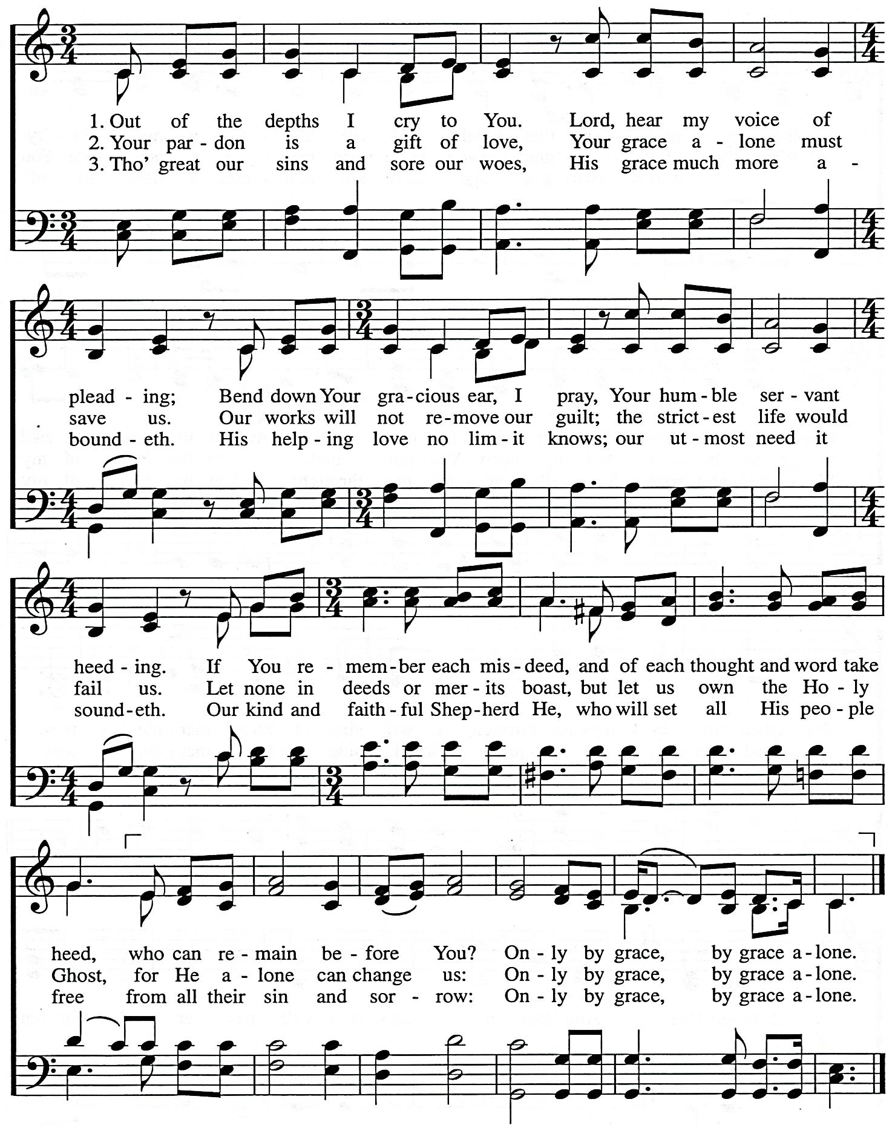

Words: Martin Luther and David L. Ward
Music: David L. Ward
2002 ThousandTongues.org. Admin. By Thousand Tongues
CCLI#1086929
Lift High the Cross
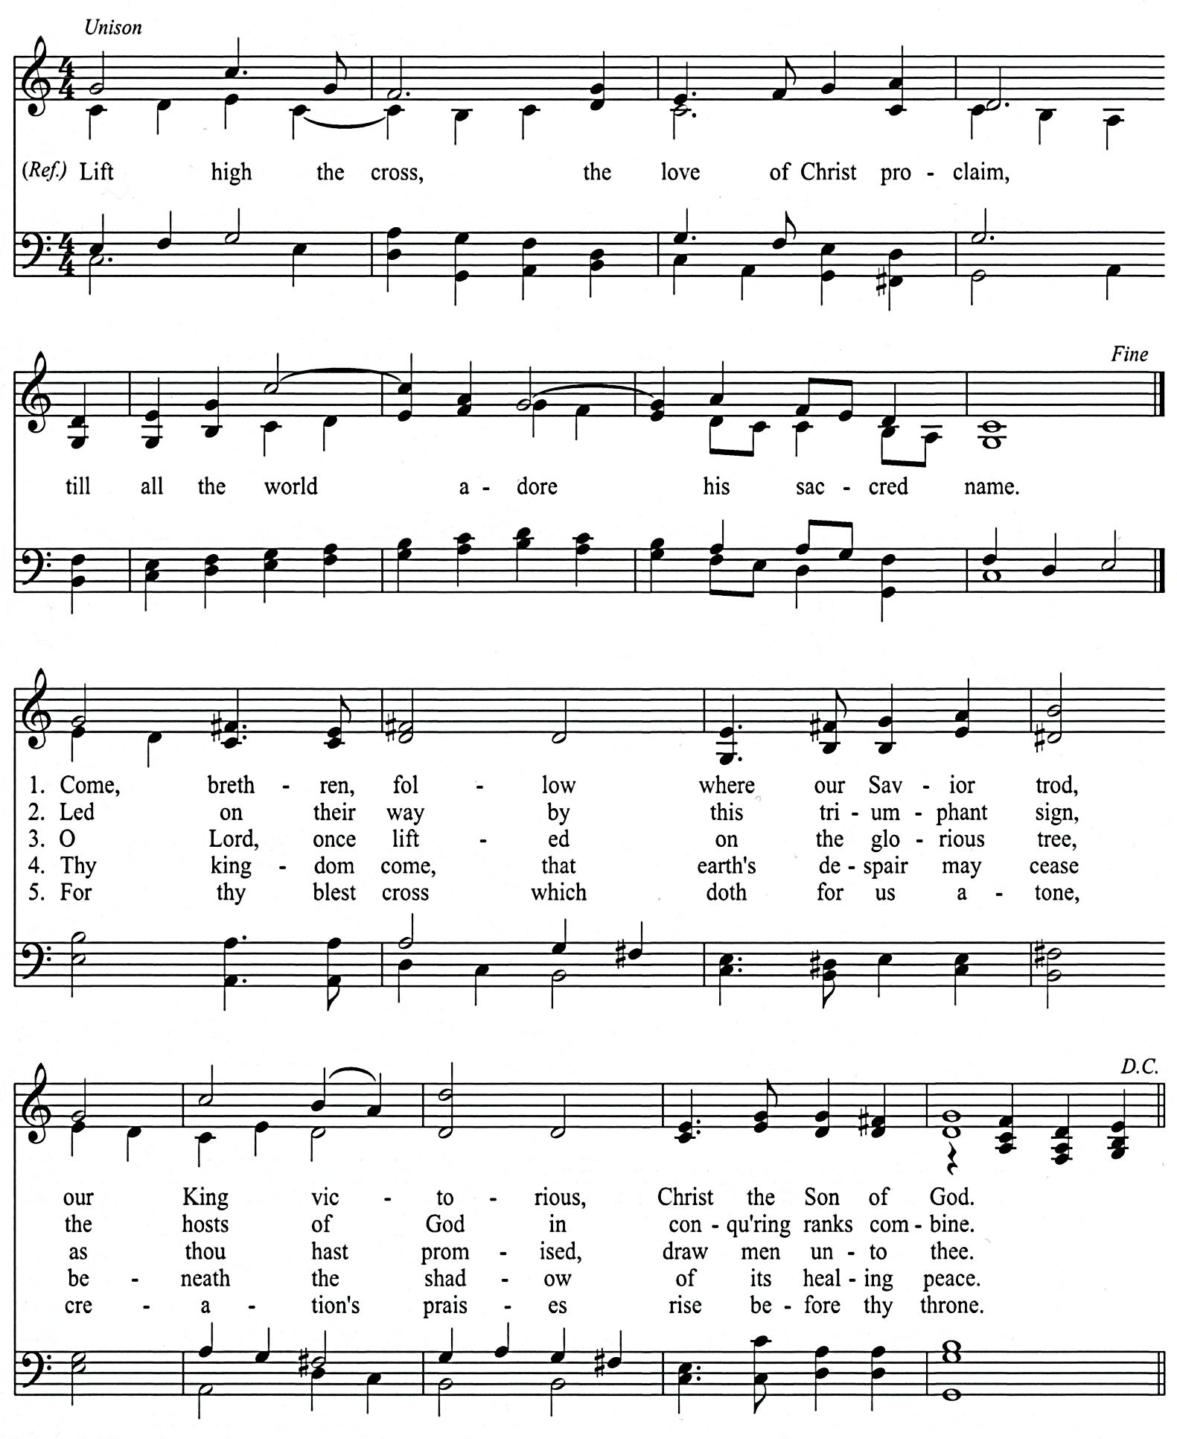

George W. Kitchin, 1887 CRUCIFER Irreg., ref.
Rev. Michael R. Newbolt, 1916; at. 1990 Sydney H. Nicholson, 1916
1974 Hope Publishing Co., Carol Stream IL 60188 www.hopepublishing.com
CCLI# 1086929 All rights reserved. Used by permission
Psalm 16A
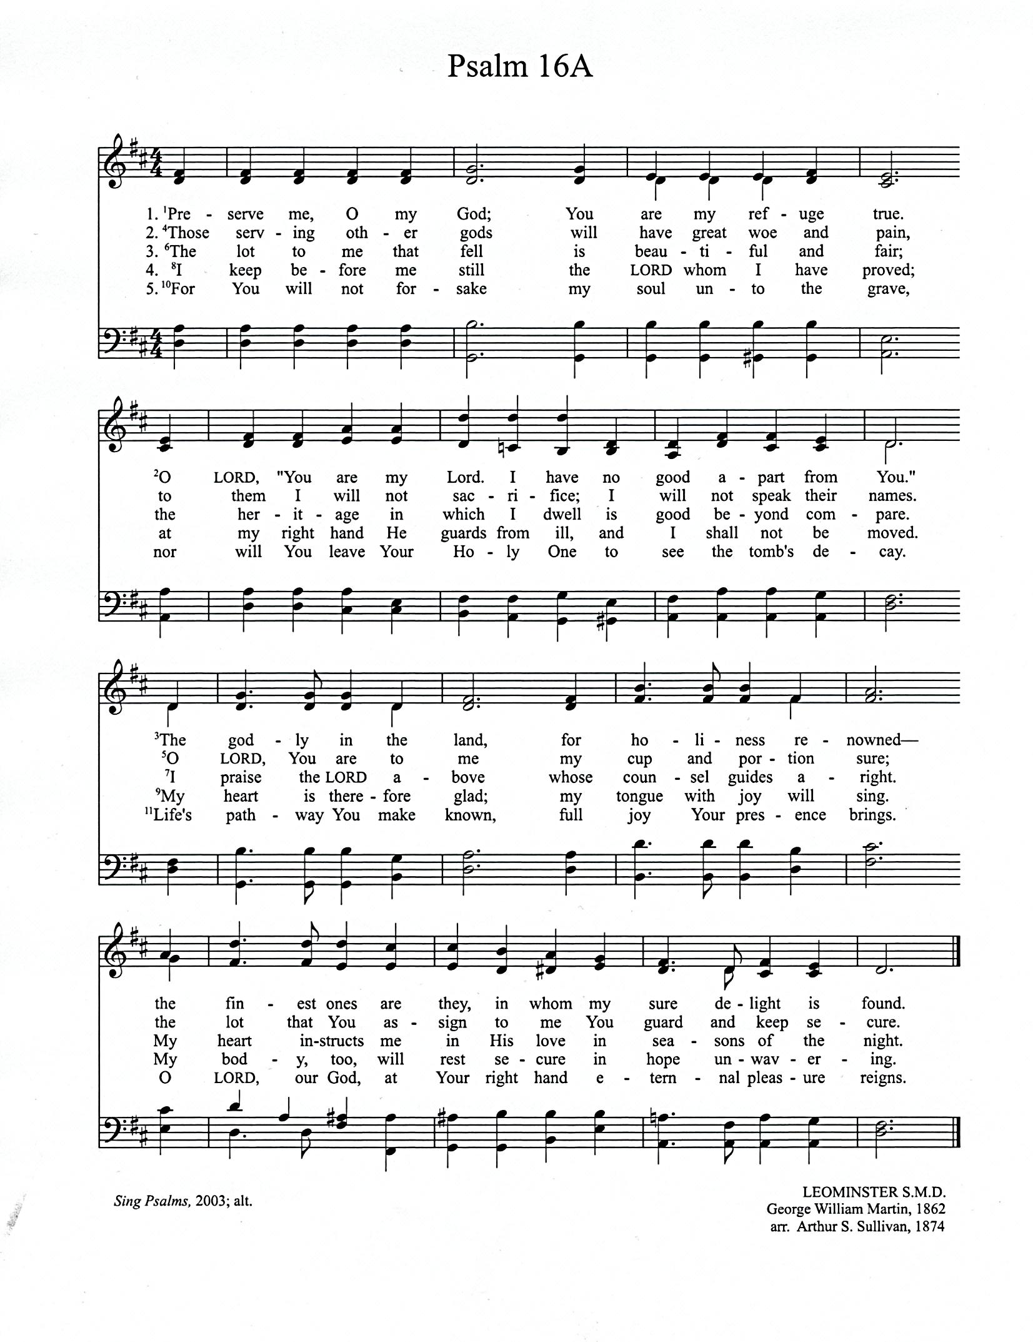

Sing Psalms, 2003; alt. LEOMASTER S.M.D.
CCLI# 1086929 George William Martin, 1862
Arr. Arthur S, Sullivan, 1874
SCHEDULES

SERVING SUNDAY – FEBRUARY 18, 2018
 |  |  | AM | PM
COOKIES |  |  | Lisa LaReau, Sarah LaReau, Donna Leep & Sharon Leep
COFFEE |  |  | Deb DeBoer
GREETERS |  |  | Dennis & Laurie Mitchell  Joseph & Linda Novosel | Terry & Diane Krooswyk  Eric & Saran LaReau
 | FLOATER |  | Mark & Lisa LaReau | Jordan & Jess Hoekstra
LIBRARY |  |  | Jorie Rottier | Karla Zandstra
NURSERY |  | INFANT | Deb Oord | Ann & Julia Oostema
 |  | FLOATER | Raylene Oord
 |  | TODDLER | Abbie & Gabriel Martin | Holly & Annalise Root & Jorie Rottier
USHERS |  |  | Josh Eenigenburg, Keith Eenigenburg & Phil Eenigenburg | Joel Eenigenburg, Kevin Eenigenburg & Kyle Eenigenburg
WELCOME WAGON |  |  | Tim & Lori Eenigenburg

SERVING SUNDAY – FEBRUARY 25, 2018
 |  |  | AM | PM
COOKIES |  |  | Abbie Martin, Nancy Martin, Bev Mesman & Laurie Mitchell
COFFEE |  |  | Deb DeBoer
GREETERS |  |  | Nick & Ashley Frederick  Howie & Karen Hoekstra | Darren & Caitlin DeBoer  Keith & Sandi Eenigenburg
 | FLOATER |  | Eric & Sarah LaReau | Bill & Alvina DeBoer
LIBRARY |  |  | Vicki VanderLaan | Judy DeBoer
NURSERY |  | INFANT | Caitlin Terpstra | Alison & Bella VanderWoude
 |  | FLOATER | Amos Terpstra
 |  | TODDLER | Jennie & Luke Terpstra | Nikki, Tori & Lexi Terpstra
USHERS |  |  | Josh Eenigenburg, Keith Eenigenburg & Phil Eenigenburg | Joel Eenigenburg, Kevin Eenigenburg & Kyle Eenigenburg
WELCOME WAGON |  |  | Kevin & Kathy Eenigenburg

FEBRUARY 2018 GIVING SCHEDULE
 | AM | PM
2/04/2018 | Bethshan | Illiana Christian High School
2/11/2018 | Providence Christian Academy | Sioux Falls URC / Rev. Aalsburg
2/18/2018 | Elim Christian School | Toronto Mission / Rev. Zekveld
2/25/2018 | Crown Point Christian School | PASS

CURC GIVING – FEBRUARY 11, 2018
General Fund | $ 3,873.00
Benevolence Fund | $ 130.00
Ceap Fund | $ 210.00
AM: Providence Christian Academy | $ 35.00
PM: Sioux Falls URC / Rev. Aalsburg | $ 20.00

SCRIPTURE FOR THE MORNING SERVICE

ISAIAH 40:18-20, 41:21-29, 42:1-9

¹⁸ To whom then will you liken God,
or what likeness compare with him?
¹⁹ An idol! A craftsman casts it,
and a goldsmith overlays it with gold
and casts for it silver chains.
²⁰ He who is too impoverished for an offering
chooses wood[ that will not rot;
he seeks out a skillful craftsman
to set up an idol that will not move.

ISAIAH 41:21-29

The Futility of Idols
²¹ Set forth your case, says the Lord;
bring your proofs, says the King of Jacob.
²² Let them bring them, and tell us
what is to happen.
Tell us the former things, what they are,
that we may consider them,
that we may know their outcome;
or declare to us the things to come.
²³ Tell us what is to come hereafter,
that we may know that you are gods;
do good, or do harm,
that we may be dismayed and terrified.
²⁴ Behold, you are nothing,
and your work is less than nothing;
an abomination is he who chooses you.
²⁵ I stirred up one from the north, and he has come,
from the rising of the sun, and he shall call upon my name;
he shall trample on rulers as on mortar,
as the potter treads clay.
²⁶ Who declared it from the beginning, that we might know,
and beforehand, that we might say, “He is right”?
There was none who declared it, none who proclaimed,
none who heard your words.
²⁷ I was the first to say[ to Zion, “Behold, here they are!”
and I give to Jerusalem a herald of good news.
²⁸ But when I look, there is no one;
among these there is no counselor
who, when I ask, gives an answer.
²⁹ Behold, they are all a delusion;
their works are nothing;
their metal images are empty wind.

ISAIAH 42:1-9

The Lord's Chosen Servant
42 Behold my servant, whom I uphold,
my chosen, in whom my soul delights;
I have put my Spirit upon him;
he will bring forth justice to the nations.
² He will not cry aloud or lift up his voice,
or make it heard in the street;
³ a bruised reed he will not break,
and a faintly burning wick he will not quench;
he will faithfully bring forth justice.
⁴ He will not grow faint or be discouraged
till he has established justice in the earth;
and the coastlands wait for his law.
⁵ Thus says God, the Lord,
who created the heavens and stretched them out,
who spread out the earth and what comes from it,
who gives breath to the people on it
and spirit to those who walk in it:
⁶ “I am the Lord; I have called you in righteousness;
I will take you by the hand and keep you;
I will give you as a covenant for the people,
a light for the nations,
⁷ to open the eyes that are blind,
to bring out the prisoners from the dungeon,
from the prison those who sit in darkness.
⁸ I am the Lord; that is my name;
my glory I give to no other,
nor my praise to carved idols.
⁹ Behold, the former things have come to pass,
and new things I now declare;
before they spring forth
I tell you of them.”

JOHN 5:19-21

¹⁹ We know that we are from God, and the whole world lies in the power of the evil one.
²⁰ And we know that the Son of God has come and has given us understanding, so that we may know him who is true; and we are in him who is true, in his Son Jesus Christ. He is the true God and eternal life.²¹ Little children, keep yourselves from idols.

SCRIPTURE FOR THE EVENING SERVICE

PSALM 146

Put Not Your Trust in Princes
146 Praise the Lord!
Praise the Lord, O my soul!
² I will praise the Lord as long as I live;
I will sing praises to my God while I have my being.

³ Put not your trust in princes,
in a son of man, in whom there is no salvation.
⁴ When his breath departs, he returns to the earth;
on that very day his plans perish.

⁵ Blessed is he whose help is the God of Jacob,
whose hope is in the Lord his God,
⁶ who made heaven and earth,
the sea, and all that is in them,
who keeps faith forever;
⁷ who executes justice for the oppressed,
who gives food to the hungry.

The Lord sets the prisoners free;
⁸ the Lord opens the eyes of the blind.
The Lord lifts up those who are bowed down;
the Lord loves the righteous.
⁹ The Lord watches over the sojourners;
he upholds the widow and the fatherless,
but the way of the wicked he brings to ruin.

¹⁰ The Lord will reign forever,
your God, O Zion, to all generations.
Praise the Lord!

ROMANS 9:5

⁵ To them belong the patriarchs, and from their race, according to the flesh, is the Christ, who is God over all, blessed forever. Amen.

1 CORINTHIANS 15:35-38

The Resurrection Body
³⁵ But someone will ask, “How are the dead raised? With what kind of body do they come?” ³⁶ You foolish person! What you sow does not come to life unless it dies. ³⁷ And what you sow is not the body that is to be, but a bare kernel, perhaps of wheat or of some other grain. ³⁸ But God gives it a body as he has chosen, and to each kind of seed its own body.

BELGIC CONFESSION, ARTICLE 19

THE UNION AND DISTINCTION OF THE TWO NATURES IN THE PERSON OF CHRIST

We believe that by this conception the person of the Son is inseparably untied and connected with the human nature; so that there are not two Sons of God, nor two persons, but two natures united in one single person; yet each nature retains its own distinct properties. As, then, the divine nature has always remained uncreated, without beginning of days or end of life, filling heaven and earth, so also has the human nature not lost its properties but remained a creature, having beginning of days, being a finite nature, and retaining all the properties of a real body. And though He has by His resurrection given immortality to the same, nevertheless He has not changed the reality of His human nature; forasmuch as our salvation and resurrection also depend on the reality of His body.
But these two natures are so closely united in one person that they were not separated even by His death. Therefore that which He, when dying, commended into the hands of His Father, was a real human spirit, departing from His body. But in the meantime the divine nature always remained united with the human, even when He lay in the grave; and the Godhead did not cease to be in Him, any more than it did when He was an infant, though it did not so clearly manifest itself for a while. Wherefore we confess that He is very God and very man; very God by His power to conquer death; and very man that He might die for us according to the infirmity of His flesh.

