Community United Reformed Church

February 25, 2018

WELCOME TO COMMUNITY!

We're glad that you're here with us today. Please join us for a time of fellowship after the service. If you're new here and have questions, speak with our pastor, one of our greeter volunteers, and/or fill out a visitor's card, located on the Visitors’ Kiosk, to help us get to know you. May God bless our worship and life together.

LARGE PRINT BULLETINS ARE AVAILABLE
ON THE VISITORS’ KIOSK OR YOU MAY ASK AN USHER

TODAY
9:30 AM Morning Worship Service
11:00 AM Sunday School & Catechism Classes
5:00 PM Evening Catechism Service
6:30 PM Psalm 150 Praise Night

BAPTISM: This morning, we witness the sacrament of holy baptism administered to Leah Song Root, daughter of Aaron and Holly Root. "He saved us, not because of works done by us in righteousness, but according to his own mercy, by the washing of regeneration and renewal of the Holy Spirit, whom he poured out on us richly through Jesus Christ our Savior" (Titus 3:5-6).

PSALM 150 PRAISE NIGHT: Tonight after the evening service, all are welcome to join in a meal and time of signing. We will be focusing on hymns and psalms celebrating Lent. If you play and instrument, bring it! Please bring a dish you love! It can be pink, red or heart shaped or none of the above.😉. It can be a side, main or dessert. This meal will be an adventure and full of surprises. Drinks will be provided. If you have any questions, please ask Andy Anderson or Derek Terpstra.

THIS WEEK
Monday 7:00 PM Ladies Prep Night*
7:30 PM Men’s Society
Tuesday 9:30 AM Women’s Morning Bible Study & Little Lambs
Lesson 9, p. 221-239
Snacks: Ann Oostema
Wednesday 7:00 PM Cadet Meeting
Cadet Pizza Order Pickup*
GEMS Meeting
Women’s Evening Bible Study
Lesson 8
Saturday 8:00 AM Men’s Forum

FUTURE EVENTS
March 10 7:00 AM-11:00 AM Community Pancake Breakfast*
March 16-17 Cornerstone Women’s Conference*
March 15-17 Classis Meetings*
April 27-28 Men’s Retreat at Gull Lake, Michigan*
June 21-24 Church Camping Trip*

*See announcements for details
**More information coming soon

ANNOUNCEMENTS
CONGRATULATIONS: We celebrate with Joel and Bethany (Krooswyk) Mance, who were united in marriage yesterday (Saturday, February 17). May our Father bless this young couple as they begin to walk life's journey together under His blessing. "Eat, friends, drink, and be drunk with love!" (Song of Solomon 5:1)

TRANSFER: The consistory has received the membership of Joshua Dykshorn, as well as the baptized memberships of his children Addylee, Mark, and Ethan, from Cornerstone Protestant Reformed Church. We will be welcoming the Dykshorns as members on Sunday, March 4, Lord willing.

BIRTHDAY: Please remember to send a card to special members of our congregation who will celebrate their birthday (addresses are in the directory):
Clara Stob – March 3
Henry Jonkman – March 5
Sam Leep – March 5

CADET PIZZA ORDERS: If you ordered pizzas from the Cadets, your order will be available for pick up on February 28 from 7-9 pm at church. Please make all checks payable to Community United Reformed Church. See Justin Bultema with any questions

CHOIR: For the month of March, our choir will begin practicing Sunday evenings following the evening service. This is in preparation for Palm Sunday, Good Friday, and Easter. All teenagers and above are welcome to join us in singing beautiful and familiar songs of praise to celebrate the death and resurrection of our Savior.

THE CHURCH SECRETARY WILL BE OUT OF THE OFFICE from February 18 – March 2. All requests and information for misc. work, flyers, etc. that need to be distributed will be completed when she returns to the office on March 6. Please place all information in the secretary mailbox in the church office. Thank you!
DISTRICT POTLUCK: There will be a potluck lunch after the morning worship service on Sunday, March 4, for the district of Elder Derek Terpstra. We will be sharing fellowship, encouragement, and food. All visitors are welcome to join us!

DOWN TO TWO AND COUNTING..... That's right! Two weeks to the CURC first responders/community pancake breakfast. Speaking of first responders, were you one of the first to respond to that annoyingly bright neon yellow/green volunteer sheet that was in your mailbox? What do you mean that you haven't turned that sheet in yet? What are you waiting for? If you "accidentally" misplaced it, I'm sure there are more available on the kiosk or member's table. If you have filled out the volunteer sheet and turned it in, please disregard this annoying announcement and a big THANK YOU! See ya'll there."

LADIES MEAL PREP NIGHT: Monday, February 26, 7:00pm in the CURC kitchen. Please bring an appetizer or dessert to share while we put together some frozen meals. These meals can be used to bring to family, friends, or neighbors in need of a loving meal! Please sign up on the kiosk. We need 2-3 ladies to bring a stand mixer. Any questions see Marcia Mitchell or Abby Jacobs.

MEN’S RETREAT: All men are invited to attend the Community Men’s Retreat, April, 27-28, 2018 at Gull Lake, Michigan! Building on the themes of discipleship, hospitality and mission we’ve been focusing on as a church, this overnight event will provide a relaxed setting to build friendships, enjoy times of learning and recreation, and foster greater unity as we seek to follow Christ together. Bill Boekestein, pastor of Immanuel Fellowship Church in Kalamazoo, Michigan will lead us in two sessions of teaching and discussion on the topics of male friendship and hospitality. Please consider making this event a priority as you plan your spring calendar. More details are on the flyer in your mailbox. Sign up on the member’s table. Contact Elder Derek Terpstra if you have any questions or need more information.

THE NEARER TO GOD DEVOTIONALS for March and April are available on the kiosk.

NURSERY PAGERS MISSING: The nursery is missing a few pagers. If you have accidentally taken them home with you, please return them as soon as possible! Thank you!

PANCAKE BREAKFAST FLYERS: All church members are encouraged to invite neighbors, friends, and co-workers to our Community Pancake Breakfast on March 10. Extra information flyers are available on the members table and the visitor’s kiosk. Contact Terry Krooswyk if you have any questions.

WOMEN’S CONFERENCE: Cornerstone United Reformed Church announces its 22nd Annual Women’s Conference—“There Is A Redeemer”— on March 16 and 17, 2018, with main speaker, Sarah Ivill, and Workshop Leader, Pastor Bob Van Manen. The signup sheet and registration/brochures detailing the conference are available on the members table. Copies are also available online at www.cornerstoneurc.com or by calling 616.669.2190. Registrations are due by March 2, 2018. This year’s conference price is $25.00 USD/person and includes breakfast and lunch on Saturday. Invite your family and friends to take advantage of this wonderful opportunity to fellowship with sisters in the faith as we glorify God together and grow in the knowledge of His Truth. Contact Nancy Martin or Barb Zandstra if you have any questions.

SERMON NOTES February 25, 2018
Rev. James Oord 9:30 am

CULTURAL IDOLATRY:
THE IDOLS OF THE WEST

Scripture Reading: Psalm 122 (p. 517) & 1 Corinthians 15:58-68 (p. 962)
Sermon Text: Psalm 122 (p. 517)

SERMON NOTES February 25, 2018
Rev. James Oord 5:00 pm

BELGIC CONFESSION:
JUSTICE AND MERCY MEET

Scripture Reading: Isaiah 30:1-18 (p. 590)
Sermon Text: Belgic Confession, Article 20 (p. 78)

May the Mind of Christ My Savior
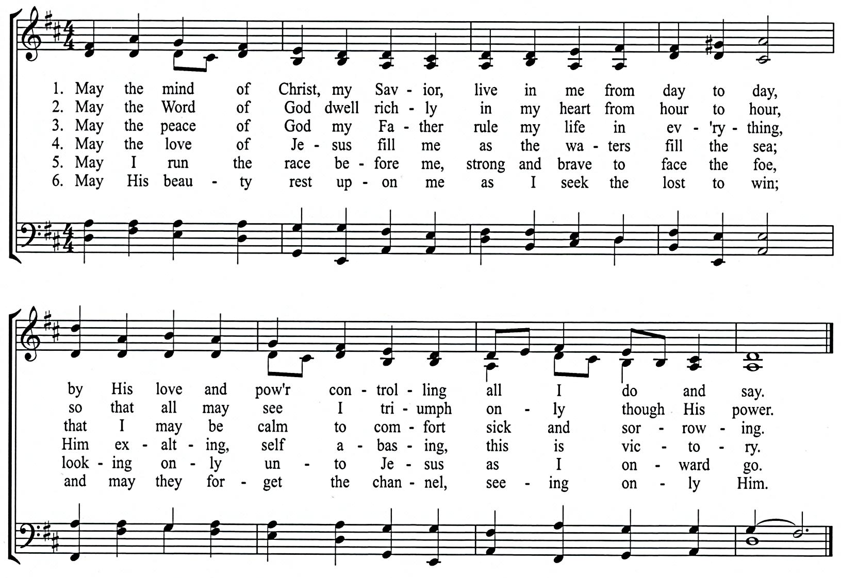

Text: Kate B. Wilson, 1925
CCLI# 1086929 Tune: A. Cyril Barham-Gould, 1925

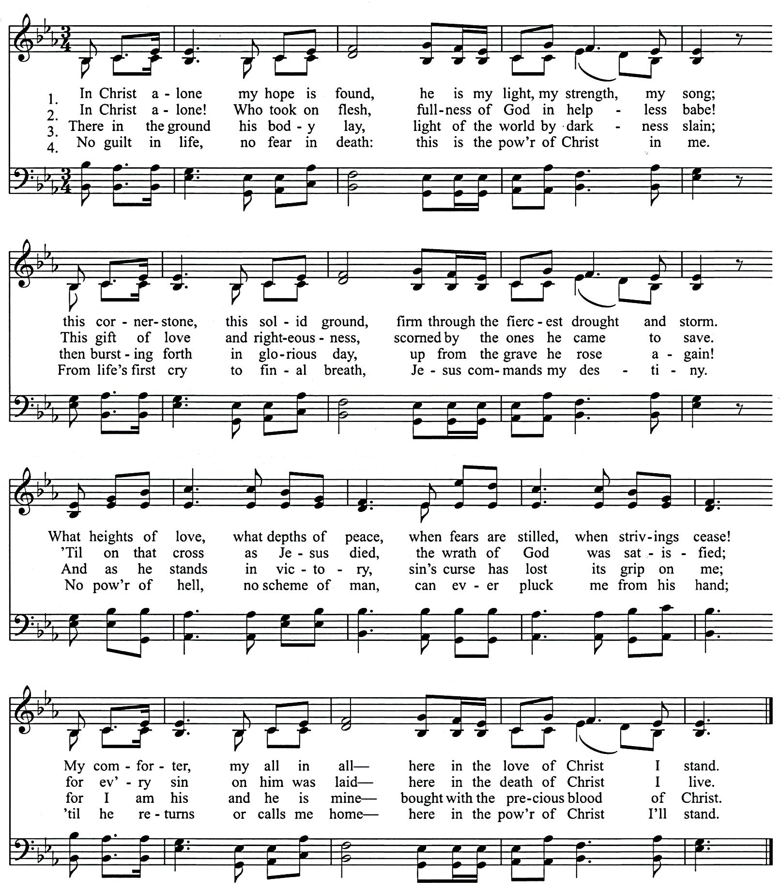
In Christ Alone

Keith Getty and Stuart Townend IN CHRIST ALONE L.M.D.
2002 Thankyou Music, adm. Worldwide by EMI CMG Publishing Keith Getty and Stuart Townend
excluding Europe which is admin, by kingswaysongs.com arr. Ruth Coleman
2002 Thankyou Music, adm. Worldwide by EMI CMG Publishing
excluding Europe which is admin, by kingswaysongs.com
(from the Trinity Psalter Hymnal of the URCNA and OPC)
CCLI# 1086929
SCHEDULES
SERVING SUNDAY – FEBRUARY 25, 2018
 |  |  | AM | PM
COOKIES |  |  | Abbie Martin, Nancy Martin, Bev Mesman & Laurie Mitchell
COFFEE |  |  | Deb DeBoer
GREETERS |  |  | Nick & Ashley Frederick  Howie & Karen Hoekstra | Darren & Caitlin DeBoer  Keith & Sandi Eenigenburg
 | FLOATER |  | Eric & Sarah LaReau | Bill & Alvina DeBoer
LIBRARY |  |  | Vicki VanderLaan | Judy DeBoer
NURSERY |  | INFANT | Caitlin Terpstra | Alison & Bella VanderWoude
 |  | FLOATER | Amos Terpstra
 |  | TODDLER | Jennie & Luke Terpstra | Nikki, Tori & Lexi Terpstra
USHERS |  |  | Josh Eenigenburg, Keith Eenigenburg & Phil Eenigenburg | Joel Eenigenburg, Kevin Eenigenburg & Kyle Eenigenburg
WELCOME WAGON |  |  | Kevin & Kathy Eenigenburg

SERVING SUNDAY – MARCH 4, 2018
 |  |  | AM | PM
COOKIES |  |  | Marcia Mitchell, Joyce Moes, Linda Novosel & Vikki Ooms
COFFEE
GREETERS |  |  | Dave Bakker  Kurt & Laura Bultema | Derek & Jennie Terpstra  Ross & Alexis VanDerNoord
 | FLOATER |  | Karen Zandstra | Grace Terpstra
LIBRARY |  |  | Barb & Beth Zandstra | Laurie Mitchell
NURSERY |  | INFANT | Danielle Bultema | Jennifer Bultema
 |  | FLOATER | Kelly Aardsma
 |  | TODDLER | Jayce & Jacob Bultema & Susan Colvin | Taytum Bultema & Jorie Rottier
USHERS |  |  | Josiah De Boer, Micah De Boer, JAK Klapak, Joe Klapak & Josh Klapak, | Jason Krooswyk, Neil Krooswyk &  Terry Krooswyk
WELCOME WAGON |  |  | District Potluck – Elder Derek Terpstra  (Joe & Nancy Martin, Dan & Deb Zandstra)

FEBRUARY 2018 GIVING SCHEDULE
 | AM | PM
2/04/2018 | Bethshan | Illiana Christian High School
2/11/2018 | Providence Christian Academy | Sioux Falls URC / Rev. Aalsburg
2/18/2018 | Elim Christian School | Toronto Mission / Rev. Zekveld
2/25/2018 | Crown Point Christian School | PASS

URCNA MISSIONS – February 25, 2018
United in Prayer: Up-to-date Requests from our Missionaries.
REV. STEVE ARRICK IS A CHURCH-PLANTER IN CAMBRIDGE, MARYLAND.
1. Pray that God might be merciful to the countless thousands of lost and unchurched people in Cambridge and the Eastern Shore by pouring out his Spirit upon them and creating in them a hunger and thirst for righteousness.
2. Pray that we may see continued interest in our work from the lost and unchurched people in Cambridge and the Eastern Shore.
3. Pray that God would continually renew our core group so that we would be useful to the Lord in introducing people to Christ.
SCRIPTURE FOR THE MORNING SERVICE

PSALM 122

Let Us Go to the House of the Lord

A SONG OF ASCENTS. OF DAVID.
122 I was glad when they said to me,
“Let us go to the house of the Lord!”
² Our feet have been standing
within your gates, O Jerusalem!

³ Jerusalem—built as a city
that is bound firmly together,
⁴ to which the tribes go up,
the tribes of the Lord,
as was decreed for Israel,
to give thanks to the name of the Lord.
⁵ There thrones for judgment were set,
the thrones of the house of David.

⁶ Pray for the peace of Jerusalem!
“May they be secure who love you!
⁷ Peace be within your walls
and security within your towers!”
⁸ For my brothers and companions' sake
I will say, “Peace be within you!”
⁹ For the sake of the house of the Lord our God,
I will seek your good.

1 CORINTHIANS 15:48-58

⁴⁸ As was the man of dust, so also are those who are of the dust, and as is the man of heaven, so also are those who are of heaven. ⁴⁹ Just as we have borne the image of the man of dust, we shall also bear the image of the man of heaven.

Mystery and Victory
⁵⁰ I tell you this, brothers: flesh and blood cannot inherit the kingdom of God, nor does the perishable inherit the imperishable. ⁵¹ Behold! I tell you a mystery. We shall not all sleep, but we shall all be changed, ⁵² in a moment, in the twinkling of an eye, at the last trumpet. For the trumpet will sound, and the dead will be raised imperishable, and we shall be changed. ⁵³ For this perishable body must put on the imperishable, and this mortal body must put on immortality. ⁵⁴ When the perishable puts on the imperishable, and the mortal puts on immortality, then shall come to pass the saying that is written:

“Death is swallowed up in victory.”
⁵⁵ “O death, where is your victory?
O death, where is your sting?”

⁵⁶ The sting of death is sin, and the power of sin is the law. ⁵⁷ But thanks be to God, who gives us the victory through our Lord Jesus Christ.
⁵⁸ Therefore, my beloved brothers, be steadfast, immovable, always abounding in the work of the Lord, knowing that in the Lord your labor is not in vain.

SCRIPTURE FOR THE EVENING SERVICE

PSALM 147

He Heals the Brokenhearted
147 Praise the Lord!
For it is good to sing praises to our God;
for it is pleasant, and a song of praise is fitting.
² The Lord builds up Jerusalem;
he gathers the outcasts of Israel.
³ He heals the brokenhearted
and binds up their wounds.
⁴ He determines the number of the stars;
he gives to all of them their names.
⁵ Great is our Lord, and abundant in power;
his understanding is beyond measure.
⁶ The Lord lifts up the humble;
he casts the wicked to the ground.

⁷ Sing to the Lord with thanksgiving;
make melody to our God on the lyre!
⁸ He covers the heavens with clouds;
he prepares rain for the earth;
he makes grass grow on the hills.
⁹ He gives to the beasts their food,
and to the young ravens that cry.
¹⁰ His delight is not in the strength of the horse,
nor his pleasure in the legs of a man,
¹¹ but the Lord takes pleasure in those who fear him,
in those who hope in his steadfast love.

¹² Praise the Lord, O Jerusalem!
Praise your God, O Zion!
¹³ For he strengthens the bars of your gates;
he blesses your children within you.
¹⁴ He makes peace in your borders;
he fills you with the finest of the wheat.
¹⁵ He sends out his command to the earth;
his word runs swiftly.
¹⁶ He gives snow like wool;
he scatters frost like ashes.
¹⁷ He hurls down his crystals of ice like crumbs;
who can stand before his cold?
¹⁸ He sends out his word, and melts them;
he makes his wind blow and the waters flow.
¹⁹ He declares his word to Jacob,
his statutes and rules to Israel.
²⁰ He has not dealt thus with any other nation;
they do not know his rules.
Praise the Lord!

ISAIAH 30:1-18

Do Not Go Down to Egypt
30 “Ah, stubborn children,” declares the Lord,
“who carry out a plan, but not mine,
and who make an alliance, but not of my Spirit,
that they may add sin to sin;
² who set out to go down to Egypt,
without asking for my direction,
to take refuge in the protection of Pharaoh
and to seek shelter in the shadow of Egypt!
³ Therefore shall the protection of Pharaoh turn to your shame,
and the shelter in the shadow of Egypt to your humiliation.
⁴ For though his officials are at Zoan
and his envoys reach Hanes,
⁵ everyone comes to shame
through a people that cannot profit them,
that brings neither help nor profit,
but shame and disgrace.”

⁶ An oracle on the beasts of the Negeb.

Through a land of trouble and anguish,
from where come the lioness and the lion,
the adder and the flying fiery serpent,
they carry their riches on the backs of donkeys,
and their treasures on the humps of camels,
to a people that cannot profit them.
⁷ Egypt's help is worthless and empty;
therefore I have called her
“Rahab who sits still.”

A Rebellious People
⁸ And now, go, write it before them on a tablet
and inscribe it in a book,
that it may be for the time to come
as a witness forever.
⁹ For they are a rebellious people,
lying children,
children unwilling to hear
the instruction of the Lord;
¹⁰ who say to the seers, “Do not see,”
and to the prophets, “Do not prophesy to us what is right;
speak to us smooth things,
prophesy illusions,
¹¹ leave the way, turn aside from the path,
let us hear no more about the Holy One of Israel.”
¹² Therefore thus says the Holy One of Israel,
“Because you despise this word
and trust in oppression and perverseness
and rely on them,
¹³ therefore this iniquity shall be to you
like a breach in a high wall, bulging out and about to collapse,
whose breaking comes suddenly, in an instant;
¹⁴ and its breaking is like that of a potter's vessel
that is smashed so ruthlessly
that among its fragments not a shard is found
with which to take fire from the hearth,
or to dip up water out of the cistern.”

¹⁵ For thus said the Lord God, the Holy One of Israel,
“In returning and rest you shall be saved;
in quietness and in trust shall be your strength.”
But you were unwilling, ¹⁶ and you said,
“No! We will flee upon horses”;
therefore you shall flee away;
and, “We will ride upon swift steeds”;
therefore your pursuers shall be swift.
¹⁷ A thousand shall flee at the threat of one;
at the threat of five you shall flee,
till you are left
like a flagstaff on the top of a mountain,
like a signal on a hill.

The Lord Will Be Gracious
¹⁸ Therefore the Lord waits to be gracious to you,
and therefore he exalts himself to show mercy to you.
For the Lord is a God of justice;
blessed are all those who wait for him.

BELGIC CONFESSION, ARTICLE 20

GOD HAS MANIFESTED HIS JUSTICE AND MERCY IN CHRIST

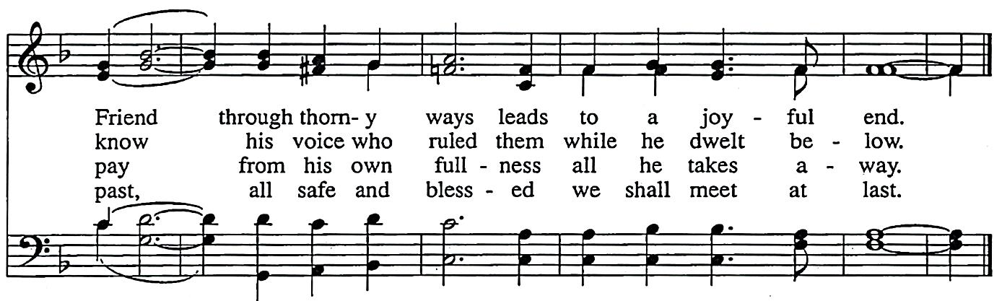
We believe that God, who is perfectly merciful and just, sent His Son to assume that nature in which the disobedience was committed, to make satisfaction in the same, and to bear the punishment of sin by His most bitter passion and death. God therefore manifested His justice against His Son when He laid our iniquities upon Him, and poured forth His mercy and goodness on us, who were guilty and worthy of damnation, out of mere and perfect love, giving His Son unto death for us, and raising Him for our justification, that through Him we might obtain immortality and life eternal.

