Community United Reformed Church

March 4, 2018

WELCOME TO COMMUNITY!

We're glad that you're here with us today. Please join us for a time of fellowship after the service. If you're new here and have questions, speak with our pastor, one of our greeter volunteers, and/or fill out a visitor's card, located on the Visitors’ Kiosk, to help us get to know you. May God bless our worship and life together.

LARGE PRINT BULLETINS ARE AVAILABLE
ON THE VISITORS’ KIOSK OR YOU MAY ASK AN USHER

TODAY
9:30 AM Morning Worship Service
11:00 AM Sunday School & Catechism Classes
5:00 PM Evening Catechism Service
6:15 PM Choir Practice*

WELCOME: this morning we welcome Joshua Dykshorn and his children Addylee, Mark, and Ethan, as members of our church family. May our Father bless us through this family and may He use us as instruments of blessing in their life as we walk this road of discipleship together. (The Dykshorns’ contact information is at the end of the new directory under “Associated with Community”.) "And may the Lord make you increase and abound in love for one another and for all, as we do for you" (I Thessalonians 3:12).

DISTRICT POTLUCK: There will be a potluck lunch after the morning worship service today for the district of Elder Derek Terpstra. We will be sharing fellowship, encouragement, and food. All visitors are welcome to join us!

CHOIR: For the month of March, our choir will begin practicing Sunday evenings following the evening service. This is in preparation for Palm Sunday, Good Friday, and Easter. All teenagers and above are welcome to join us in singing beautiful and familiar songs of praise to celebrate the death and resurrection of our Savior.

THIS WEEK
Monday 7:30 PM Men’s Society
Tuesday 9:30 AM Women’s Morning Bible Study & Little Lambs
Lesson 10 (p. 243-245)
Snacks: Kathy DeYoung
Wednesday Women’s Afternoon Bible Study
12:00 PM Sack Lunch
1:00 PM Lesson 8
Snacks: Grace Terpstra & Eileen Zandstra
7:00 PM Elders’ Meeting
7:30 PM Deacons’ Meeting
Saturday 7:00 AM-11:00 AM Community Pancake Breakfast*
8:00 AM Men’s Forum

FUTURE EVENTS
March 16-17 Cornerstone Women’s Conference*
March 15-17 Classis Meetings*
April 27-28 Men’s Retreat at Gull Lake, Michigan*
June 21-24 Church Camping Trip*

*See announcements for details
**More information coming soon

ANNOUNCEMENTS
BIRTHDAY: Please remember to send a card to special members of our congregation who will celebrate their birthday (addresses are in the directory):
Henry Jonkman – March 5
Sam Leep – March 5

THE CHURCH SECRETARY WILL BE OUT OF THE OFFICE from February 18 – March 2. All requests and information for misc. work, flyers, etc. that need to be distributed will be completed when she returns to the office on March 6. Please place all information in the secretary mailbox in the church office. Thank you!

COURIER: The deadline for the next issue is March 18. Articles may be placed in the Courier mailbox in the office or they may be emailed to the church at curcoffice@sbcglobal.net. Any interesting news items and photos of the congregation would be appreciated.

FOOD & DIAPER DRIVE: We continue to collect items for the Food and Diaper table during the entire year. Please bring in your donated items to support the Beacon Light food bank and the Women's Center.

MEN’S RETREAT: All men are invited to attend the Community Men’s Retreat, April, 27-28, 2018 at Gull Lake, Michigan! Building on the themes of discipleship, hospitality and mission we’ve been focusing on as a church, this overnight event will provide a relaxed setting to build friendships, enjoy times of learning and recreation, and foster greater unity as we seek to follow Christ together. Bill Boekestein, pastor of Immanuel Fellowship Church in Kalamazoo, Michigan will lead us in two sessions of teaching and discussion on the topics of male friendship and hospitality. Please consider making this event a priority as you plan your spring calendar. More details are on the flyer in your mailbox. Sign up on the member’s table. Contact Elder Derek Terpstra if you have any questions or need more information.

THE NEARER TO GOD DEVOTIONALS for March and April are available on the kiosk.

NURSERY: Please sign up on the members table if you are willing to add your name to serve in the nursery.

ONE FOR THE MONEY, TWO FOR THE SHOW, THREE TO GET READY, AND FOUR,"LET'S GO!" Ya'll ready for dis? This is the week you've been waiting for. In case you don't remember what you've been waiting for, it's pancake time. Even if you forgot to sign up to volunteer, just show up and we'll find something for you to do that will just make your whole Saturday stupendous. If Rev. Oord and Rev. DeBoer can volunteer to come out and sing Broadway show tunes at each table for the entire time, you can certainly show up and help for a few hours. You'll regret it if you miss out, and don't forget to drag your neighbors to come out and sample some CURC hospitality. It's gonna be great.

PANCAKE BREAKFAST FLYERS: All church members are encouraged to invite neighbors, friends, and co-workers to our Community Pancake Breakfast on March 10. Extra information flyers are available on the members table and the visitor’s kiosk. Contact Terry Krooswyk if you have any questions.

WHEELCHAIRS are available for congregation or visitor use and are located at each entrance. If you are in need of wheelchair assistance to and from the parking lot, please contact Tim Eenigenburg.

WOMEN’S CONFERENCE: Cornerstone United Reformed Church announces its 22nd Annual Women’s Conference—“There Is A Redeemer”— on March 16 and 17, 2018, with main speaker, Sarah Ivill, and Workshop Leader, Pastor Bob Van Manen. The signup sheet and registration/brochures detailing the conference are available on the members table. Copies are also available online at www.cornerstoneurc.com or by calling 616.669.2190. Registrations are due by March 2, 2018. This year’s conference price is $25.00 USD/person and includes breakfast and lunch on Saturday. Invite your family and friends to take advantage of this wonderful opportunity to fellowship with sisters in the faith as we glorify God together and grow in the knowledge of His Truth. Contact Nancy Martin or Barb Zandstra if you have any questions.

Community Pancake Breakfast

To show appreciation for our neighbors
and our First Responders!

Community United Reformed Church
8405 Alexander Street
Schererville, IN 46374

March 10
7 am – 11 am

FREE!!

All you can eat!!!
All are welcome!!!

SERMON NOTES March 4, 2018
Rev. James Oord 9:30 am

CULTURAL IDOLATRY:
RELATIONSHIPS

Scripture Reading: Genesis 29 (p. 23) & John 1:1-18 (p. 886)
Sermon Text: Genesis 29 (p. 23)

SERMON NOTES March 4, 2018
Rev. James Oord 5:00 pm

BELGIC CONFESSION:
THE ATONEMENT

Scripture Reading: Hebrews 10:1-22 (p. 1006)
Sermon Text: Belgic Confession, Article 21 (p. 79)

Oh, to See the Dawn (Power of the Cross)
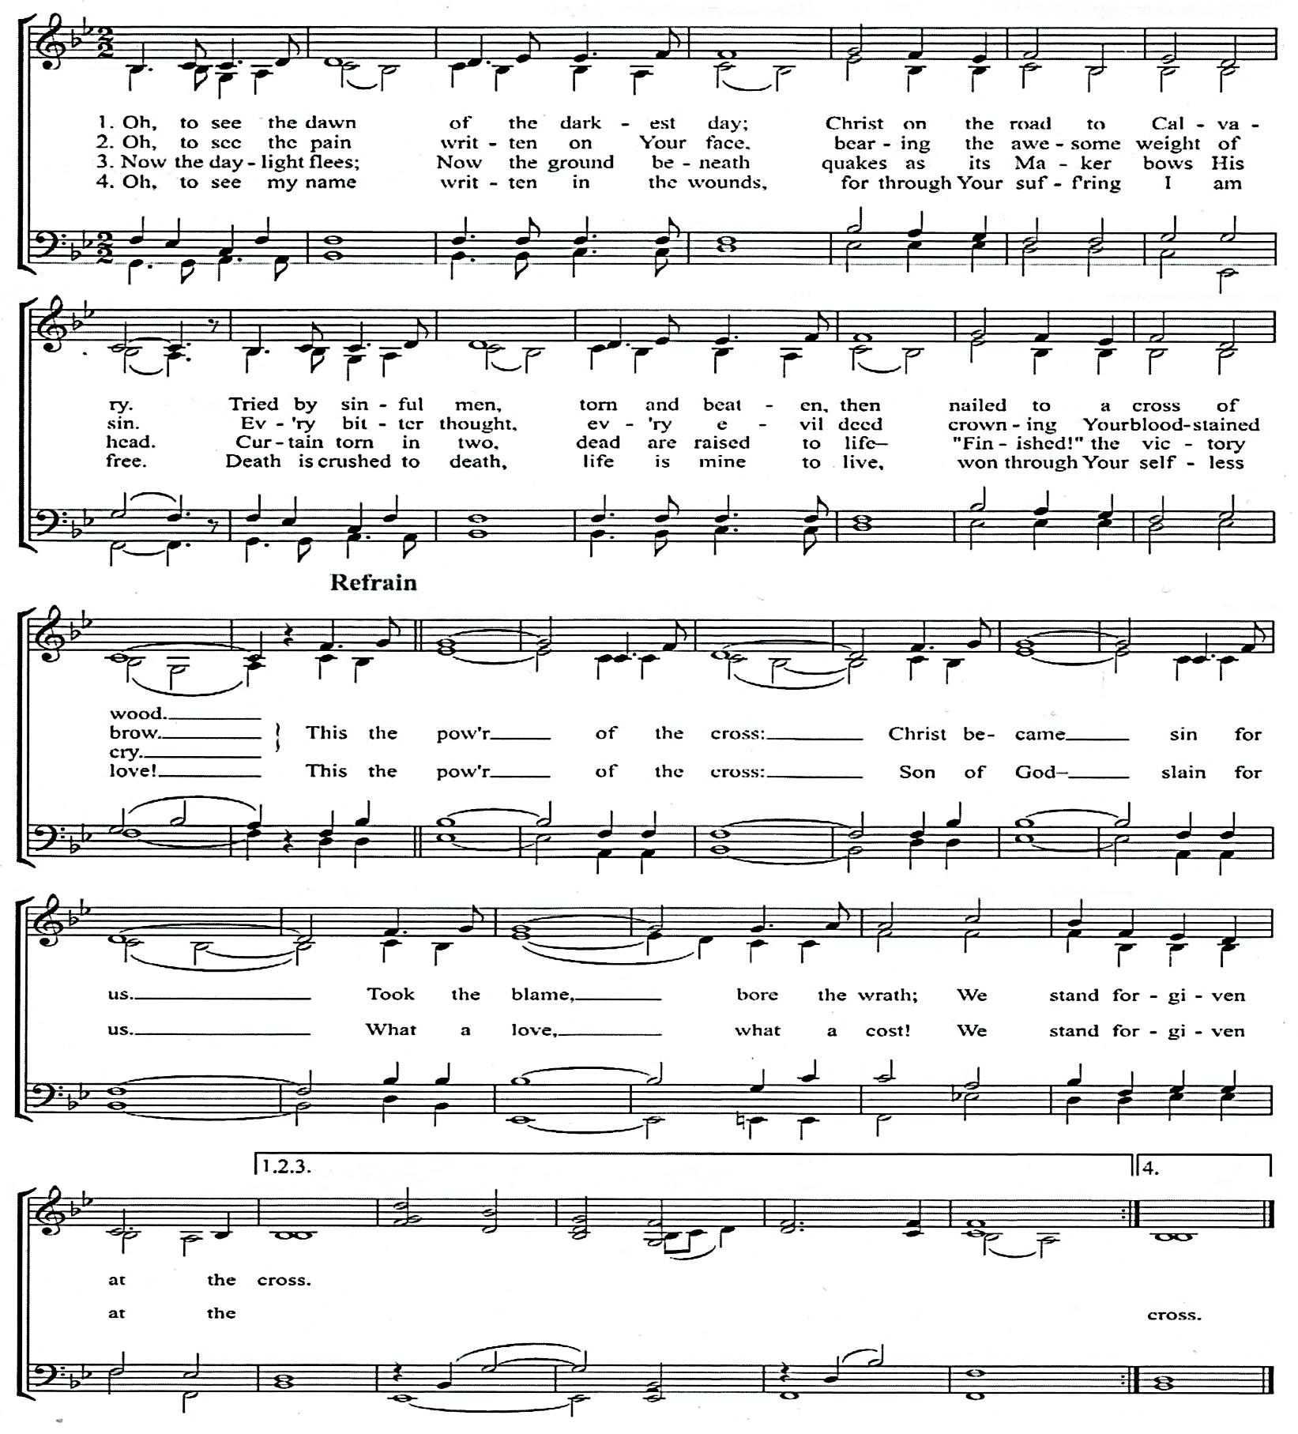

Copyright 2005 Thankyou Music/Adm. By worshiptogether.com songs Words and Music by
Excl. UK & Europe, adm. By Kingsway Music. tym@kingsway.co.uk. Keith Getty & Stuart Townend
Used by permission
CCLI# 1086929
O Great God
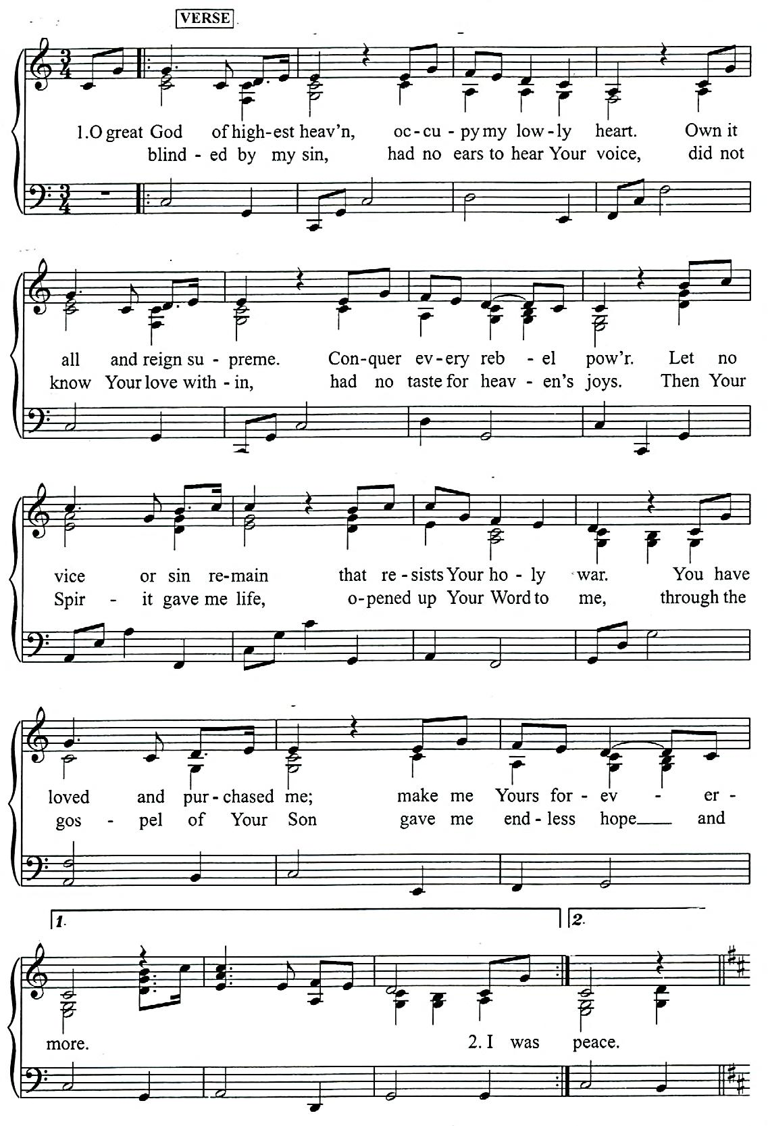

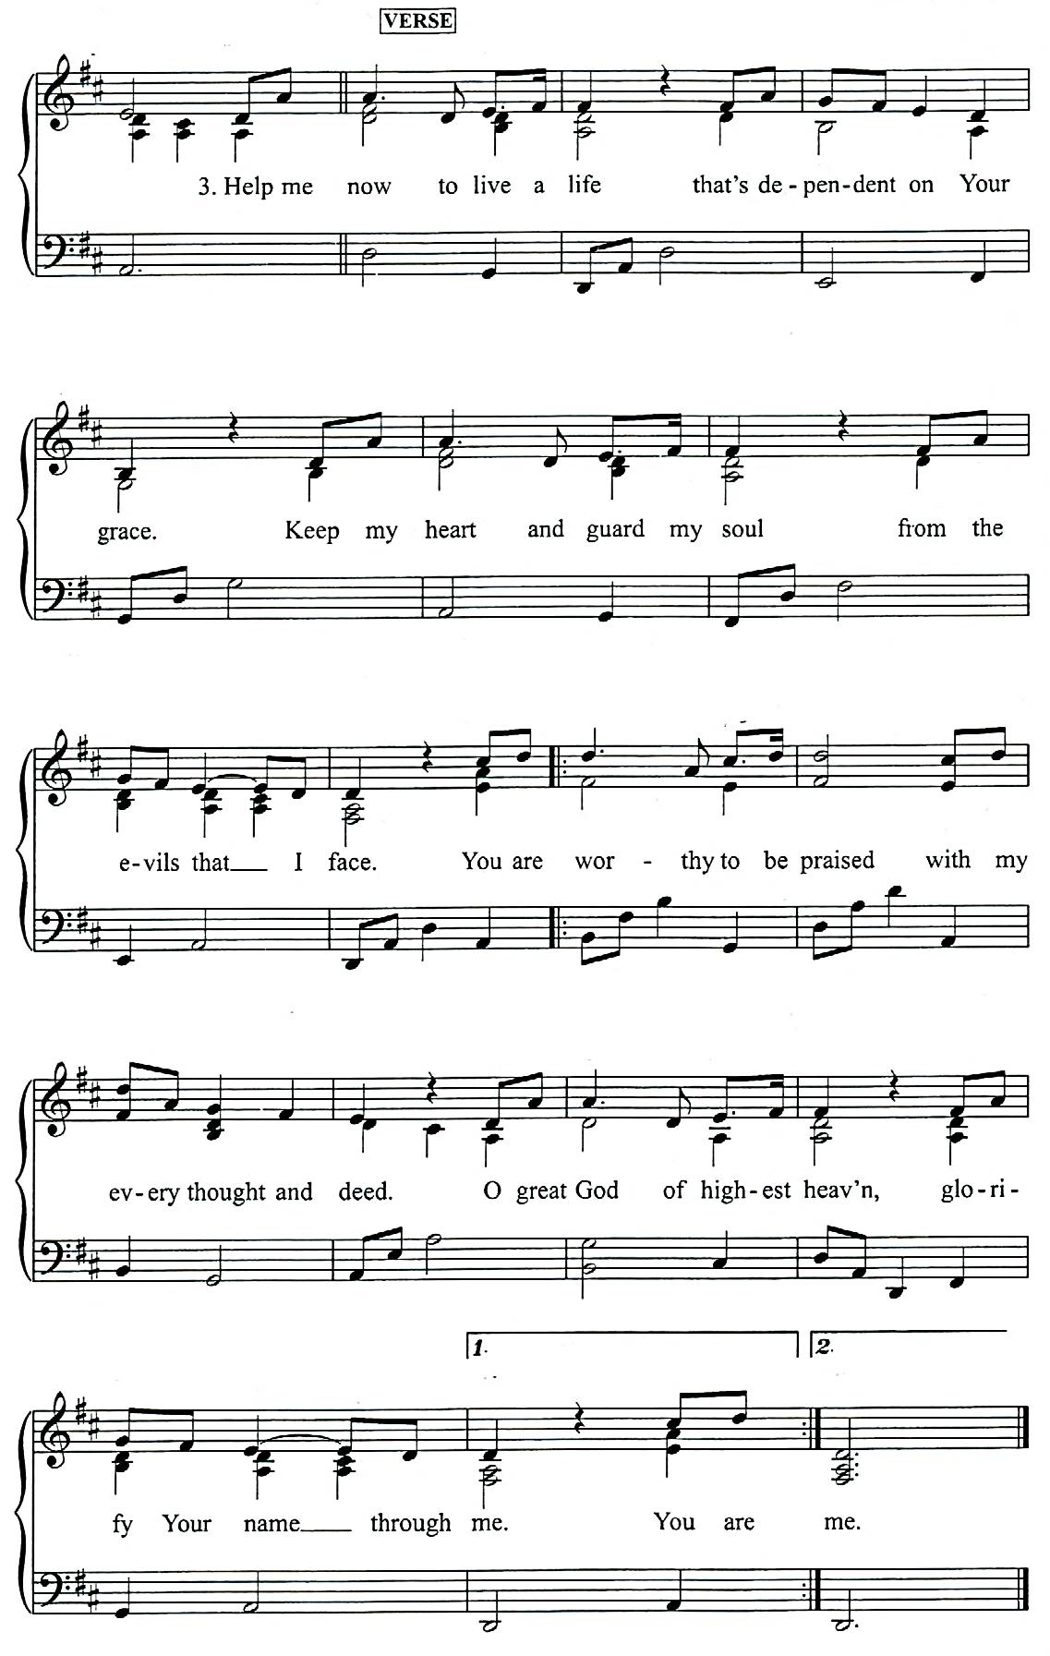

Music and words: Bob Kauflin
2006 Sovereign Grace Praise (BMI). Sovereign Grace Music, a division of Sovereign Grace Ministries.
From Valley of Vision. All rights reserved. International copyright secured.
Administration by Integrity Music.
CCLI# 1086929
Responsive Reading
based on the 1st Commandment

Leader: “Owe no one anything, except to love each other, for the one who loves another has fulfilled the law. For the commandments… are summed up in this word…” (Romans 13:8-9)

People: “You shall love the Lord your God with all your heart and with all your soul and with all your mind. This is the great and first commandment. And a second is like it: You shall love your neighbor as yourself” (Matthew 22:37-39).

Leader: “And God spoke all these words, saying, ‘I am the LORD your God, who brought you out of the land of Egypt, out of the house of slavery. You shall have no other gods before me’” (Exodus 20:1-2).

People: “Therefore, my beloved, flee from idolatry” (I Corinthians 10:14).

Leader: Idolatry is having or inventing something in which one trusts in place of or alongside of the only true God, who has revealed Himself in His Word (Heidelberg Catechism, Q&A 95).

People: “Formerly, when you did not know God, you were enslaved to those that by nature are not gods” (Galatians 4:8).

Leader: “But now that you have come to know God - or rather, to be known by God - how can you turn back again to the weak and worthless elementary principles of the world, whose slaves you want to be once more? (Galatians 4:9).

People: “For God alone, O my soul, wait in silence, for my hope is from Him” (Psalm 62:5).

Leader: “Thus says the LORD: ‘Cursed is the man who trusts in man and makes flesh his strength, whose heart turns away from the LORD… blessed is the man who trusts in the LORD, whose trust is in the LORD” (Jeremiah 17:5,7).

People: “All who fashion idols are nothing, and the things they delight in do not profit… Those who make them become like them; so do all who trust in them” (Isaiah 44:9, Psalm 115:8).

Leader: Let us confess our lack of honor for God and turn to Jesus Christ for forgiveness, “that all may honor the Son, just as they honor the Father. Whoever does not honor the Son does not honor the Father who sent Him” (John 5:23).

People: “Search me, O God, and know my heart! Try me and know my thoughts! And see if there be any grievous way in me, and lead me in the way everlasting” (Psalm 139:23-24).

Leader: “Seek the LORD while He may be found; call upon Him while He is near; let the wicked forsake his way, and the unrighteous man his thoughts; let him return to the LORD, that He may have compassion upon him, and to our God, for He will abundantly pardon” (Isaiah 55:6-7).

People: “Whom have I in heaven but You? And there is nothing on earth that I desire besides you. My flesh and my heart may fail, but God is the strength of my heart and my portion forever” (Psalm 73:25-26).

Leader: The Word of the Lord.

People: Thanks be to God.

SCHEDULES

SERVING SUNDAY – MARCH 4, 2018
 |  |  | AM | PM
COOKIES |  |  | Marcia Mitchell, Joyce Moes, Linda Novosel & Vikki Ooms
COFFEE
GREETERS |  |  | Dave Bakker  Kurt & Laura Bultema | Derek & Jennie Terpstra  Ross & Alexis VanDerNoord
 | FLOATER |  | Karen Zandstra | Grace Terpstra
LIBRARY |  |  | Barb & Beth Zandstra | Laurie Mitchell
NURSERY |  | INFANT | Danielle Bultema | Jennifer Bultema
 |  | FLOATER | Kelly Aardsma
 |  | TODDLER | Jayce & Jacob Bultema & Susan Colvin | Taytum Bultema & Jorie Rottier
USHERS |  |  | Josiah De Boer, Micah De Boer, JAK Klapak, Joe Klapak & Josh Klapak, | Jason Krooswyk, Neil Krooswyk &  Terry Krooswyk
WELCOME WAGON |  |  | District Potluck – Elder Derek Terpstra  (Joe & Nancy Martin, Dan & Deb Zandstra)

SERVING SUNDAY – MARCH 11, 2018
 |  |  | AM | PM
COOKIES |  |  | Deb Oord, Raylene Oord, Ann Oostema & Olivette Ortiz
COFFEE
GREETERS |  |  | Dan & Carol Rottier  Steve & Alison VanderWoude | Scott & Vikki Ooms  Bryan & Debra Punter
 | FLOATER |  | Gerry & Sandi Swets | Joseph & Linda Novosel
LIBRARY |  |  | Nancy Martin | Jennie Terpstra
NURSERY |  | INFANT | Sandi Eenigenburg | Pam Hart
 |  | FLOATER | Anna De Boer
 |  | TODDLER | Caitlin DeBoer & Isaac Eenigenburg | Holly, Annalise & Leah Root
USHERS |  |  | Josiah De Boer, Micah De Boer, JAK Klapak, Joe Klapak & Josh Klapak,
WELCOME WAGON |  |  | Bill & Alvina DeBoer

MARCH 2018 GIVING SCHEDULE
 | AM | PM
3/04/2018 | Elim Christian School | Classis Central U.S.
3/11/2018 | DeMotte Christian School | Illiana Christian High School
3/18/2018 | Reformed Youth Services | GEMS
3/25/2018 | URCNA | Calvanist Cadet Corps

SCRIPTURE FOR THE MORNING SERVICE

GENESIS 29

Jacob Marries Leah and Rachel
29 Then Jacob went on his journey and came to the land of the people of the east. ² As he looked, he saw a well in the field, and behold, three flocks of sheep lying beside it, for out of that well the flocks were watered. The stone on the well's mouth was large, ³ and when all the flocks were gathered there, the shepherds would roll the stone from the mouth of the well and water the sheep, and put the stone back in its place over the mouth of the well.
⁴ Jacob said to them, “My brothers, where do you come from?” They said, “We are from Haran.” ⁵ He said to them, “Do you know Laban the son of Nahor?” They said, “We know him.” ⁶ He said to them, “Is it well with him?” They said, “It is well; and see, Rachel his daughter is coming with the sheep!” ⁷ He said, “Behold, it is still high day; it is not time for the livestock to be gathered together. Water the sheep and go, pasture them.” ⁸ But they said, “We cannot until all the flocks are gathered together and the stone is rolled from the mouth of the well; then we water the sheep.”
⁹ While he was still speaking with them, Rachel came with her father's sheep, for she was a shepherdess. ¹⁰ Now as soon as Jacob saw Rachel the daughter of Laban his mother's brother, and the sheep of Laban his mother's brother, Jacob came near and rolled the stone from the well's mouth and watered the flock of Laban his mother's brother. ¹¹ Then Jacob kissed Rachel and wept aloud. ¹² And Jacob told Rachel that he was her father's kinsman, and that he was Rebekah's son, and she ran and told her father.
¹³ As soon as Laban heard the news about Jacob, his sister's son, he ran to meet him and embraced him and kissed him and brought him to his house. Jacob told Laban all these things, ¹⁴ and Laban said to him, “Surely you are my bone and my flesh!” And he stayed with him a month.
¹⁵ Then Laban said to Jacob, “Because you are my kinsman, should you therefore serve me for nothing? Tell me, what shall your wages be?”¹⁶ Now Laban had two daughters. The name of the older was Leah, and the name of the younger was Rachel. ¹⁷ Leah's eyes were weak, but Rachel was beautiful in form and appearance. ¹⁸ Jacob loved Rachel. And he said, “I will serve you seven years for your younger daughter Rachel.” ¹⁹ Laban said, “It is better that I give her to you than that I should give her to any other man; stay with me.” ²⁰ So Jacob served seven years for Rachel, and they seemed to him but a few days because of the love he had for her.
²¹ Then Jacob said to Laban, “Give me my wife that I may go in to her, for my time is completed.” ²² So Laban gathered together all the people of the place and made a feast. ²³ But in the evening he took his daughter Leah and brought her to Jacob, and he went in to her. ²⁴ (Laban gave his female servant Zilpah to his daughter Leah to be her servant.) ²⁵ And in the morning, behold, it was Leah! And Jacob said to Laban, “What is this you have done to me? Did I not serve with you for Rachel? Why then have you deceived me?” ²⁶ Laban said, “It is not so done in our country, to give the younger before the firstborn. ²⁷ Complete the week of this one, and we will give you the other also in return for serving me another seven years.” ²⁸ Jacob did so, and completed her week. Then Laban gave him his daughter Rachel to be his wife. ²⁹ (Laban gave his female servant Bilhah to his daughter Rachel to be her servant.) ³⁰ So Jacob went in to Rachel also, and he loved Rachel more than Leah, and served Laban for another seven years.

Jacob's Children
³¹ When the Lord saw that Leah was hated, he opened her womb, but Rachel was barren. ³² And Leah conceived and bore a son, and she called his name Reuben, for she said, “Because the Lord has looked upon my affliction; for now my husband will love me.” ³³ She conceived again and bore a son, and said, “Because the Lord has heard that I am hated, he has given me this son also.” And she called his name Simeon. ³⁴ Again she conceived and bore a son, and said, “Now this time my husband will be attached to me, because I have borne him three sons.” Therefore his name was called Levi. ³⁵ And she conceived again and bore a son, and said, “This time I will praise the Lord.” Therefore she called his name Judah. Then she ceased bearing.

JOHN 1:1-18

The Word Became Flesh
1 In the beginning was the Word, and the Word was with God, and the Word was God. ² He was in the beginning with God. ³ All things were made through him, and without him was not any thing made that was made. ⁴ In him was life, and the life was the light of men. ⁵ The light shines in the darkness, and the darkness has not overcome it.
⁶ There was a man sent from God, whose name was John. ⁷ He came as a witness, to bear witness about the light, that all might believe through him. ⁸ He was not the light, but came to bear witness about the light.
⁹ The true light, which gives light to everyone, was coming into the world. ¹⁰ He was in the world, and the world was made through him, yet the world did not know him. ¹¹ He came to his own, and his own people did not receive him. ¹² But to all who did receive him, who believed in his name, he gave the right to become children of God,¹³ who were born, not of blood nor of the will of the flesh nor of the will of man, but of God.
¹⁴ And the Word became flesh and dwelt among us, and we have seen his glory, glory as of the only Son from the Father, full of grace and truth. ¹⁵ (John bore witness about him, and cried out, “This was he of whom I said, ‘He who comes after me ranks before me, because he was before me.’”) ¹⁶ For from his fullness we have all received, grace upon grace. ¹⁷ For the law was given through Moses; grace and truth came through Jesus Christ. ¹⁸ No one has ever seen God; the only God, who is at the Father's side, he has made him known.

SCRIPTURE FOR THE EVENING SERVICE

PSALM 148

Praise the Name of the Lord
148 Praise the Lord!
Praise the Lord from the heavens;
praise him in the heights!
² Praise him, all his angels;
praise him, all his hosts!

³ Praise him, sun and moon,
praise him, all you shining stars!
⁴ Praise him, you highest heavens,
and you waters above the heavens!

⁵ Let them praise the name of the Lord!
For he commanded and they were created.
⁶ And he established them forever and ever;
he gave a decree, and it shall not pass away.

⁷ Praise the Lord from the earth,
you great sea creatures and all deeps,
⁸ fire and hail, snow and mist,
stormy wind fulfilling his word!

⁹ Mountains and all hills,
fruit trees and all cedars!
¹⁰ Beasts and all livestock,
creeping things and flying birds!

¹¹ Kings of the earth and all peoples,
princes and all rulers of the earth!
¹² Young men and maidens together,
old men and children!

¹³ Let them praise the name of the Lord,
for his name alone is exalted;
his majesty is above earth and heaven.
¹⁴ He has raised up a horn for his people,
praise for all his saints,
for the people of Israel who are near to him.
Praise the Lord!

HEBREWS 10:1-22

Christ's Sacrifice Once for All
10 For since the law has but a shadow of the good things to come instead of the true form of these realities, it can never, by the same sacrifices that are continually offered every year, make perfect those who draw near. ² Otherwise, would they not have ceased to be offered, since the worshipers, having once been cleansed, would no longer have any consciousness of sins? ³ But in these sacrifices there is a reminder of sins every year. ⁴ For it is impossible for the blood of bulls and goats to take away sins.
⁵ Consequently, when Christ came into the world, he said,

“Sacrifices and offerings you have not desired,
but a body have you prepared for me;
⁶ in burnt offerings and sin offerings
you have taken no pleasure.
⁷ Then I said, ‘Behold, I have come to do your will, O God,
as it is written of me in the scroll of the book.’”

⁸ When he said above, “You have neither desired nor taken pleasure in sacrifices and offerings and burnt offerings and sin offerings” (these are offered according to the law), ⁹ then he added, “Behold, I have come to do your will.” He does away with the first in order to establish the second. ¹⁰ And by that will we have been sanctified through the offering of the body of Jesus Christ once for all.
¹¹ And every priest stands daily at his service, offering repeatedly the same sacrifices, which can never take away sins. ¹² But when Christ had offered for all time a single sacrifice for sins, he sat down at the right hand of God, ¹³ waiting from that time until his enemies should be made a footstool for his feet. ¹⁴ For by a single offering he has perfected for all time those who are being sanctified.
¹⁵ And the Holy Spirit also bears witness to us; for after saying,

¹⁶ “This is the covenant that I will make with them
after those days, declares the Lord:
I will put my laws on their hearts,
and write them on their minds,”

¹⁷ then he adds,

“I will remember their sins and their lawless deeds no more.”

¹⁸ Where there is forgiveness of these, there is no longer any offering for sin.

The Full Assurance of Faith
¹⁹ Therefore, brothers, since we have confidence to enter the holy places by the blood of Jesus, ²⁰ by the new and living way that he opened for us through the curtain, that is, through his flesh, ²¹ and since we have a great priest over the house of God, ²² let us draw near with a true heart in full assurance of faith, with our hearts sprinkled clean from an evil conscience and our bodies washed with pure water.

BELGIC CONFESSION, ARTICLE 21

THE SATISFACTION OF CHRIST, OUR ONLY HIGH PRIEST, FOR US

We believe that Jesus Christ is ordained with an oath to be an everlasting High Priest, after the order of Melchizedek; and that He has presented Himself in our behalf before the Father, to appease His wrath by His full satisfaction, by offering Himself on the tree of the cross, and pouring out His precious blood to purge away our sins, as the prophets had foretold. For it is written: He was wounded for our transgressions, he was bruised for our iniquities; the chastisement of our peace was upon him; and with his stripes we are healed. He was led as a lamb to the slaughter, and numbered with the transgressors; and condemned by Pontius Pilate as a malefactor, though he had first declared Him innocent. Therefore, He restored that which he took not away, and suffered, the righteous for the unrighteous, as well in His body as in His soul; feeling the terrible punishment which our sins had merited; insomuch that his sweat became as it were great drops of blood falling down upon the ground. He called out: My God, my God, why hast thou forsaken me? and has suffered all this for the remission of our sins.
Wherefore we justly say with the apostle Paul that we know nothing save Jesus Christ, and him crucified; we count all things but loss and refuse for the excellency of the knowledge of Christ Jesus our Lord, in whose wounds we find all manner of consolation. Neither is it necessary to seek or invent any other means of being reconciled to God than this only sacrifice, once offered, by which he hath perfected forever them that are sanctified. This is also the reason why He was called by the angel of God, JESUS, that is to say, SAVIOR, because He would save his people from their sins.

