Community United Reformed Church

March 11, 2018

WELCOME TO COMMUNITY!

We're glad that you're here with us today. Please join us for a time of fellowship after the service. If you're new here and have questions, speak with our pastor, one of our greeter volunteers, and/or fill out a visitor's card, located on the Visitors’ Kiosk, to help us get to know you. May God bless our worship and life together.

LARGE PRINT BULLETINS ARE AVAILABLE
ON THE VISITORS’ KIOSK OR YOU MAY ASK AN USHER

TODAY
9:30 AM Morning Worship Service
11:00 AM Sunday School & Catechism Classes
5:00 PM Evening Catechism Service
6:15 PM Choir Practice*

CHOIR: For the month of March, our choir will begin practicing Sunday evenings following the evening service. This is in preparation for Palm Sunday, Good Friday, and Easter. All teenagers and above are welcome to join us in singing beautiful and familiar songs of praise to celebrate the death and resurrection of our Savior.

THIS WEEK
Monday 7:30 PM Men’s Prayer Meeting
Tuesday 9:30 AM Women’s Morning Bible Study & Little Lambs
Lesson 10 (p. 246-265)
Snacks: Abby Jacobs
Wednesday 7:00 PM Cadet Meeting
GEMS Meeting
Women’s Evening Bible Study
Lesson 9
Thursday 7:00 PM Classis Seminar*
Friday – Saturday various Classis Central U.S. Meetings*
Friday – Saturday Women’s Conference*
Saturday 8:00 AM Men’s Forum

FUTURE EVENTS
March 30 5:45 PM Good Friday Potluck*
March 30 7:00 PM Good Friday Service*
April 27-28 Men’s Retreat at Gull Lake, Michigan*
June 21-24 Church Camping Trip*

*See announcements for details
**More information coming soon

ANNOUNCEMENTS
BAPTISM: The elders have accepted David Muller's request to join our church. David will be baptized during the morning service on April 8. We praise God for His work in David's life in leading him to a life of discipleship with Jesus. We pray that as part of our church family, he will be a blessing to us and that we will have many opportunities to be a blessing to him.

REAFFIRMATION OF FAITH: The elders have accepted Robin Muller's request to join our church. As part of becoming a member of our church, Robin will be reaffirming her faith during the morning service on April 8. We pray that as part of our church family, she will be a blessing to us and that we will have many opportunities to be a blessing to her.

TRANSFER: the consistory has received the memberships of Scott and Lynette Swets from Faith Church in Dyer. We will be welcoming the Swets as members on March 25, Lord willing. May the Lord bless the Swets in our church family and continue to use them to be a blessing to us.
CHRISTIAN SYMPATHY: We express our Christian sympathy to Bea Siersema, Dave & Diane Siersema, and Dan & Kathy DeYoung as they mourn the loss of Richard VanderWoude. Richard is Bea Siersema's brother and Dan DeYoung's uncle. He passed into glory on February 23. Please keep Richard's family and friends in your prayers as they grieve. "He will swallow up death forever; and the LORD God will wipe away tears from all faces, and the reproach of his people he will take away from all the earth, for the LORD has spoken." (Isaiah 25:8)

CHRISTIAN SYMPATHY: We express our Christian sympathy to Terry & Diane Krooswyk, Jason Krooswyk, Neil & Allie Krooswyk, and Joel & Bethany Mance as they mourn the loss of Terry's brother Russ Krooswyk. Russ passed into glory on February 15. Please keep Russ' family and friends in your prayers as they grieve. Jesus said, "So also you have sorrow now, but I will see you again, and your hearts will rejoice, and no one will take your joy from you... take heart; I have overcome the world.” (John 16:22, 33)

CHRISTIAN SYMPATHY: We express our Christian sympathy to Donna Leep and the Klapak family as they mourn the loss of Donna's sister-in-law Eleanor Porter. Eleanor passed into glory on February 16. Please keep Eleanor's family and friends in your prayers as they grieve. "For God has not destined us for wrath, but to obtain salvation through our Lord Jesus Christ, who died for us so that whether we are awake or asleep we might live with him." (I Thessalonians 5:9-10)

THANK YOU to our church family for the visits, cards, gifts, and prayers while I was in the hospital. We appreciate everyone’s love and support during this time as I am in the process of healing.
—Alexis and Ross VanDerNoord

THANK YOU: A huge "THANK YOU" to everyone who helped out planning, setting up, serving, grilling, flipping, mixing, mingling, greeting, cleaning, etc., at the Pancake Breakfast. Thank you for inviting our friends and neighbors. Thank you for praying for the success of this event. Please continue to be in prayer for our church to form meaningful relationships within our community and to welcome others in Christ's name as Christ has welcomed us for the glory of God (Romans 15:7).

BIBLE LEAGUE VOLUNTEERS invite you to their Spring Luncheon at Teibel’s Restaurant on Thursday, March 22, at 11:30 am. Featured soloist will be Sarah Van Drunen. Offering for Bibles for Latin America will be taken. Ticket deadline is March 15. The cost is $18 for chicken and $22 for perch. Call Barb Zandstra at 219.924.5778 for tickets.

COURIER: The deadline for the next issue is March 18. Articles may be placed in the Courier mailbox in the office or they may be emailed to the church at curcoffice@sbcglobal.net. Any interesting news items and photos of the congregation would be appreciated.

DAILY PRAYER REMINDERS for the month of March are in your mailbox and on the Visitors’ Kiosk.

GOOD FRIDAY POTLUCK: You are invited to attend the Good Friday Potluck to be held on Friday, March 30 at 5:45 pm before the Good Friday Service which will be held at 7:00 pm. More details are on the flyer in your mailbox. Please sign up on the fellowship committee table with your name, how many are attending, and what you would like to bring (main dish, large salad, vegetable casserole or dessert). Beverages will be provided. Contact Lori or Tim Eenigenburg if you have any questions.

GOOD FRIDAY SERVICES: Our Good Friday worship service is scheduled for Friday, April 14 at 7:00 pm. During that service we will be celebrating the sacrament of the Lord's Supper. Professing members of the congregation are encouraged to prepare themselves for the sacrament according to the apostle Paul's instructions in 1 Corinthians 11.

MEN’S RETREAT: All men are invited to attend the Community Men’s Retreat, April, 27-28, 2018 at Gull Lake, Michigan! Building on the themes of discipleship, hospitality and mission we’ve been focusing on as a church, this overnight event will provide a relaxed setting to build friendships, enjoy times of learning and recreation, and foster greater unity as we seek to follow Christ together. Bill Boekestein, pastor of Immanuel Fellowship Church in Kalamazoo, Michigan will lead us in two sessions of teaching and discussion on the topics of male friendship and hospitality. Please consider making this event a priority as you plan your spring calendar. More details are on the flyer in your mailbox. Sign up on the member’s table. Contact Elder Derek Terpstra if you have any questions or need more information.

PEANUT-FREE COOKIE REQUEST: Due to allergies of members and visitors, we are transitioning towards making our church a peanut-free zone. More information will follow, but for now, we do request that if you are bringing cookies, snacks, or meal to a church event, please refrain from bringing anything containing peanuts or cooked in peanut oil for the safety and peace of mind of those who attend Community.

SUPPER CLUB – SPRING/SUMMER 2018: You are invited to join our church Supper Club. Supper Club is for all adults (single or married). It is a great way to get to know others in our church family! Please sign up on the kiosk and check the appropriate box if you would like to join, remain on the list, or if you would like to take your name off of the list. The deadline to sign up is March 25! See the flyer in your mailbox for more details! Call Karla Zandstra if you have any questions.

WOMEN’S CONFERENCE: Cornerstone United Reformed Church announces its 22nd Annual Women’s Conference—“There Is A Redeemer”— on March 16 and 17, 2018, with main speaker, Sarah Ivill, and Workshop Leader, Pastor Bob Van Manen. The signup sheet and registration/brochures detailing the conference are available on the members table. Copies are also available online at www.cornerstoneurc.com or by calling 616.669.2190. Registrations are due by March 2, 2018. This year’s conference price is $25.00 USD/person and includes breakfast and lunch on Saturday. Invite your family and friends to take advantage of this wonderful opportunity to fellowship with sisters in the faith as we glorify God together and grow in the knowledge of His Truth. Contact Nancy Martin or Barb Zandstra if you have any questions.

URCNA MISSIONS – March 11, 2018
United in Prayer: Up-to-date Requests from our Missionaries.
REV. BILL GREEN IS MISSIONARY IN SAN JOSE, COSTA RICA.
1) Praise for the new "Ministry Center building" which is now being used by three Reformed ministries: The Christian High school, the CLIR ministry and print shop, and the Pacto de Gracia congregation!
2) The CLIR printing operation will be losing its pressman in a month. Please pray that the Lord provide an ideal person for our needs.
3) Latin America is being assaulted severely by the LGTB forces, and already there is discrimination and persecution of those who don't agree. Pray for our churches, our school, and for the many concerned parents.

CLASSIS CENTRAL US
ANNOUNCEMENTS

CLASSIS CENTRAL US: This week Thursday-Saturday, Classis will be meeting at our church. Classis Central US is the regional body of URCNA churches with whom we share close fellowship. We meet to encourage, discuss, and give advice on matters common to all of us. We will be sharing this meeting the Presbytery of the Midwest of the Orthodox Presbyterian Church, a denomination with whom we have much in common (including the new Trinity Psalter Hymnal). Please pray for wisdom and pray for a spirit of unity and ecumenicity as we meet together with brothers from the OPC.

CLASSIS HELP NEEDED: Wednesday night, we need assistance in setting up tables and chairs for the Classis Meeting. If you are able to help, please be at church at 8:30pm (after Cadets and GEMS).

CLASSIS HELP NEEDED: We are still in need of kitchen help for the classis meeting. Please speak to Cheryl Terpstra if you are able to assist.

CLASSIS SEMINAR: "Ministry to Those Struggling with Sexual Sin": Part of our meeting with the OPC will be a seminar led by Rev. Tim Geiger. Rev. Geiger is executive director of Harvest USA, an excellent Reformed counseling ministry that specializes in biblical sexuality (www.harvestusa.org). His presentation will be of great benefit to our pastors and elders. This seminar is also open to the public. It will be held Thursday, March 15, at 7:00pm, at our church. We encourage you to come hear about this timely topic.

SERMON NOTES March 11, 2018
Rev. James Oord 9:30 am

CULTURAL IDOLATRY:
MAMMON

Scripture Reading: Psalm 62 (p. 479) & Matthew 6:19-34 (p. 811)
Sermon Text: Psalm 62 (p. 479)

SERMON NOTES March 11, 2018
Rev. James Oord 5:00 pm

BELGIC CONFESSION:
SOLA FIDE

Scripture Reading: Romans 3:19-4:25 (p. 941)
Sermon Text: Belgic Confession, Article 22 (p. 79)

I’ll Not Be Shaken
(Psalm 62)
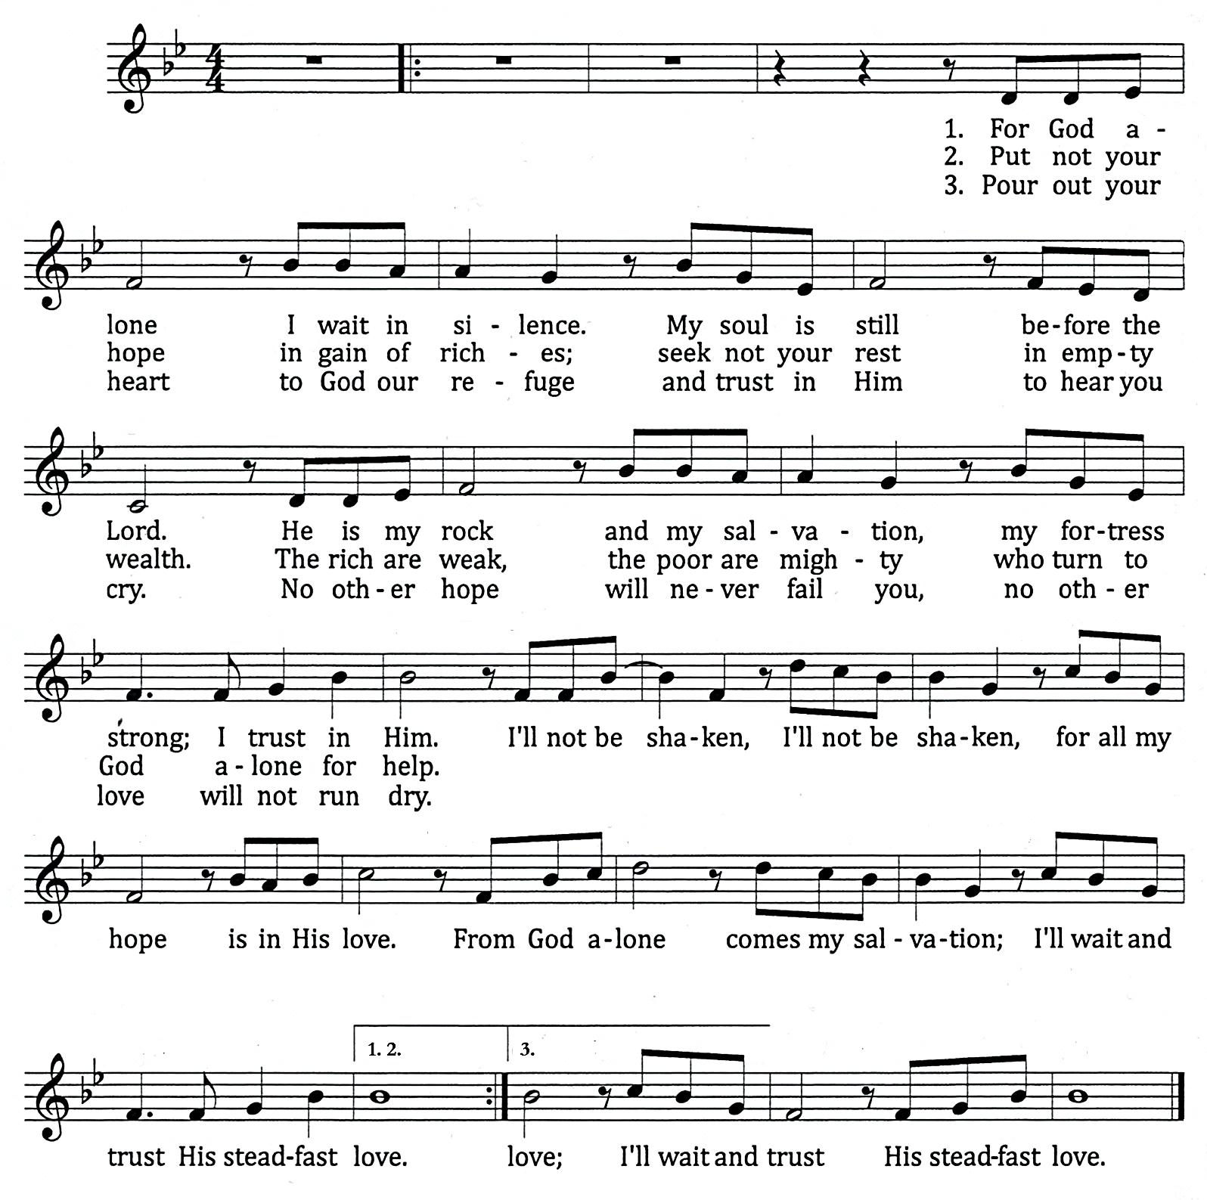

2015 Wendell Kimbrough, wendellk.com CCLI Song #7064722
CCLI# 1086929
Be Thou My Vision
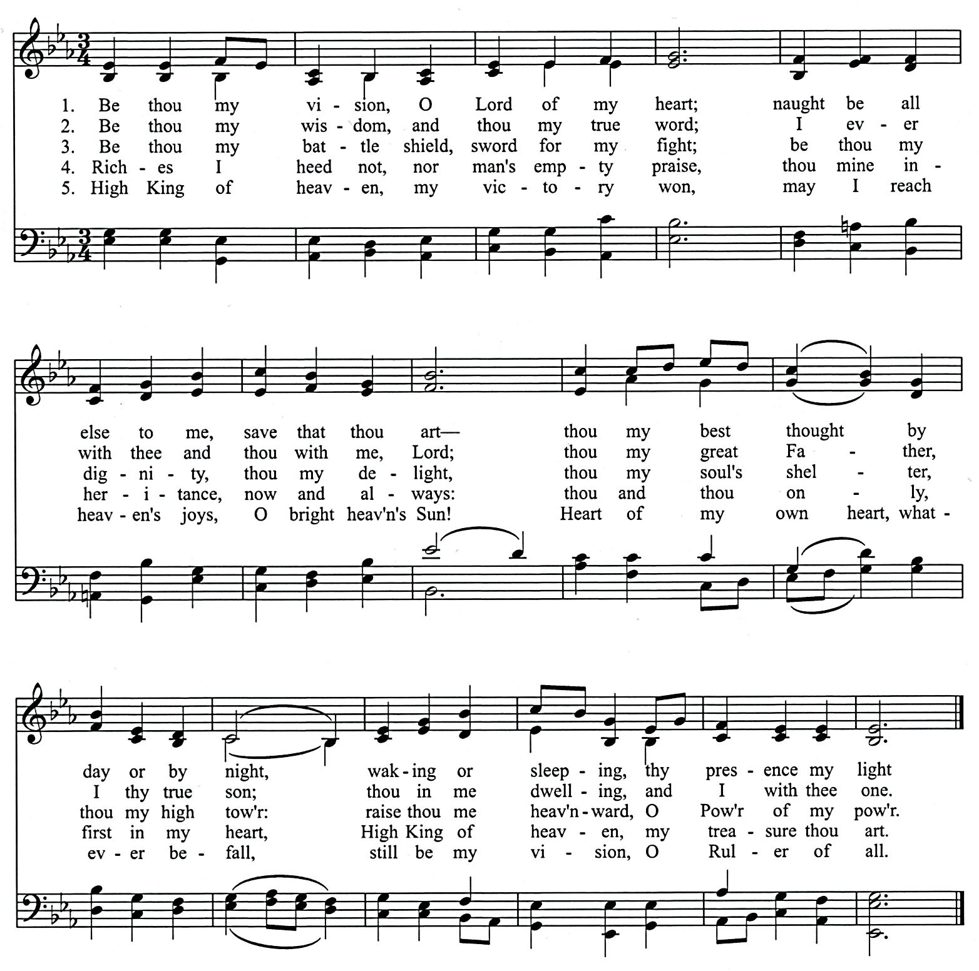

Ancient Irish poem, ca. 8th cent. SLANE 10.10.1010.
Tr. By Mary E. Bryne, 1905 Traditional Irish melody
Versified by Eleanor H. Hull, 1912
(from the Trinity Psalter Hymnal of the URCNA and OPC)
CCLI# 1086929
You are invited to attend a
Good Friday
Potluck

Before the service on Good Friday
March 30, 2018 at 5:45 pm

Please sign up on the
MEMBERS TABLE
with your name,
how many are attending
&
Indicate what you
would like to bring.

You may choose one of
The following to bring
To the potluck:
(Beverages will be provided)

Main Dish
Large Salad
Vegetable Casserole
Dessert

Contact
Tim or Lori Eenigenburg
if you have any questions

CURC GIVING – FEBRUARY 18, 2018
General Fund | $ 4,945.00
Benevolence Fund | $ 265.00
Ceap Fund | $ 95.00
AM: Elim Christian School | $ 536.15
PM: Toronto Mission / Rev. Zekveld | $ 234.00

CURC GIVING – FEBRUARY 25, 2018
General Fund | $ 13,420.75
Benevolence Fund | $ 435.00
Ceap Fund | $ 1,328.00
AM: Crown Point Christian School | $ 437.66
PM: PASS | $ 492.00

CURC GIVING – MARCH 4, 2018
General Fund | $ 17,400.00
Benevolence Fund | $ 110.00
Ceap Fund | $ 220.00
AM: DeMotte Christian School | $ 455.65
PM: Illiana Christian High School | $ 262.00

SCHEDULES

SERVING SUNDAY – MARCH 11, 2018
 |  |  | AM | PM
COOKIES |  |  | Deb Oord, Raylene Oord, Ann Oostema & Olivette Ortiz
COFFEE
GREETERS |  |  | Dan & Carol Rottier  Steve & Alison VanderWoude | Scott & Vikki Ooms  Bryan & Debra Punter
 | FLOATER |  | Gerry & Sandi Swets | Joseph & Linda Novosel
LIBRARY |  |  | Nancy Martin | Jennie Terpstra
NURSERY |  | INFANT | Sandi Eenigenburg | Pam Hart
 |  | FLOATER | Anna De Boer
 |  | TODDLER | Caitlin DeBoer & Isaac Eenigenburg | Holly, Annalise & Leah Root
USHERS |  |  | Josiah De Boer, Micah De Boer, JAK Klapak, Joe Klapak & Josh Klapak,
WELCOME WAGON |  |  | Rev. Jeff & Karen De Boer

SERVING SUNDAY – MARCH 18, 2018
 |  |  | AM | PM
COOKIES |  |  | Cindy Poortenga, Deb Punter, Cecelia Rietveld & Holly Root
COFFEE
GREETERS |  |  | Mark & Lisa LaReau  Dennis & Laurie Mitchell | Jordan & Jess Hoekstra  Terry & Diane Krooswyk
 | FLOATER |  | Eric & Sarah LaReau | Howie & Karen Hoekstra
LIBRARY |  |  | Jennifer Bultema | Steve & Alison VanderWoude
NURSERY |  | INFANT | Kristen Huizenga | Tabitha Eenigenburg
 |  | FLOATER | Laurie Huizenga
 |  | TODDLER | Kathy & Brandon DeYoung | Kathy & Kyle Eenigenburg
USHERS |  |  | Josiah De Boer, Micah De Boer, JAK Klapak, Joe Klapak & Josh Klapak, | Jason Krooswyk, Neil Krooswyk &  Terry Krooswyk
WELCOME WAGON |  |  | Andy & Rose Anderson

MARCH 2018 GIVING SCHEDULE
 | AM | PM
3/04/2018 | Elim Christian School | Classis Central U.S.
3/11/2018 | DeMotte Christian School | Illiana Christian High School
3/18/2018 | Reformed Youth Services | GEMS
3/25/2018 | URCNA | Calvanist Cadet Corps

SCRIPTURE FOR THE MORNING SERVICE

PSALM 62

My Soul Waits for God Alone

TO THE CHOIRMASTER: ACCORDING TO JEDUTHUN. A PSALM OF DAVID.
62 For God alone my soul waits in silence;
from him comes my salvation.
² He alone is my rock and my salvation,
my fortress; I shall not be greatly shaken.

³ How long will all of you attack a man
to batter him,
like a leaning wall, a tottering fence?
⁴ They only plan to thrust him down from his high position.
They take pleasure in falsehood.
They bless with their mouths,
but inwardly they curse. Selah

⁵ For God alone, O my soul, wait in silence,
for my hope is from him.
⁶ He only is my rock and my salvation,
my fortress; I shall not be shaken.
⁷ On God rests my salvation and my glory;
my mighty rock, my refuge is God.

⁸ Trust in him at all times, O people;
pour out your heart before him;
God is a refuge for us. Selah

⁹ Those of low estate are but a breath;
those of high estate are a delusion;
in the balances they go up;
they are together lighter than a breath.
¹⁰ Put no trust in extortion;
set no vain hopes on robbery;
if riches increase, set not your heart on them.

¹¹ Once God has spoken;
twice have I heard this:
that power belongs to God,
¹² and that to you, O Lord, belongs steadfast love.
For you will render to a man
according to his work.

MATTHEW 6:19-34

Lay Up Treasures in Heaven
¹⁹ “Do not lay up for yourselves treasures on earth, where moth and rust destroy and where thieves break in and steal, ²⁰ but lay up for yourselves treasures in heaven, where neither moth nor rust destroys and where thieves do not break in and steal. ²¹ For where your treasure is, there your heart will be also.
²² “The eye is the lamp of the body. So, if your eye is healthy, your whole body will be full of light, ²³ but if your eye is bad, your whole body will be full of darkness. If then the light in you is darkness, how great is the darkness!
²⁴ “No one can serve two masters, for either he will hate the one and love the other, or he will be devoted to the one and despise the other. You cannot serve God and money.

Do Not Be Anxious
²⁵ “Therefore I tell you, do not be anxious about your life, what you will eat or what you will drink, nor about your body, what you will put on. Is not life more than food, and the body more than clothing? ²⁶ Look at the birds of the air: they neither sow nor reap nor gather into barns, and yet your heavenly Father feeds them. Are you not of more value than they?²⁷ And which of you by being anxious can add a single hour to his span of life? ²⁸ And why are you anxious about clothing? Consider the lilies of the field, how they grow: they neither toil nor spin, ²⁹ yet I tell you, even Solomon in all his glory was not arrayed like one of these. ³⁰ But if God so clothes the grass of the field, which today is alive and tomorrow is thrown into the oven, will he not much more clothe you, O you of little faith? ³¹ Therefore do not be anxious, saying, ‘What shall we eat?’ or ‘What shall we drink?’ or ‘What shall we wear?’ ³² For the Gentiles seek after all these things, and your heavenly Father knows that you need them all. ³³ But seek first the kingdom of God and his righteousness, and all these things will be added to you.
³⁴ “Therefore do not be anxious about tomorrow, for tomorrow will be anxious for itself. Sufficient for the day is its own trouble.

SCRIPTURE FOR THE EVENING SERVICE

PSALM 149

Sing to the Lord a New Song
149 Praise the Lord!
Sing to the Lord a new song,
his praise in the assembly of the godly!
² Let Israel be glad in his Maker;
let the children of Zion rejoice in their King!
³ Let them praise his name with dancing,
making melody to him with tambourine and lyre!
⁴ For the Lord takes pleasure in his people;
he adorns the humble with salvation.
⁵ Let the godly exult in glory;
let them sing for joy on their beds.
⁶ Let the high praises of God be in their throats
and two-edged swords in their hands,
⁷ to execute vengeance on the nations
and punishments on the peoples,
⁸ to bind their kings with chains
and their nobles with fetters of iron,
⁹ to execute on them the judgment written!
This is honor for all his godly ones.
Praise the Lord!

ROMANS 3:19-4:25

¹⁹ Now we know that whatever the law says it speaks to those who are under the law, so that every mouth may be stopped, and the whole world may be held accountable to God. ²⁰ For by works of the law no human being will be justified in his sight, since through the law comes knowledge of sin.

The righteousness of god through faith
²¹ But now the righteousness of God has been manifested apart from the law, although the Law and the Prophets bear witness to it— ²² the righteousness of God through faith in Jesus Christ for all who believe. For there is no distinction: ²³ for all have sinned and fall short of the glory of God, ²⁴ and are justified by his grace as a gift, through the redemption that is in Christ Jesus, ²⁵ whom God put forward as a propitiation by his blood, to be received by faith. This was to show God's righteousness, because in his divine forbearance he had passed over former sins. ²⁶ It was to show his righteousness at the present time, so that he might be just and the justifier of the one who has faith in Jesus.
²⁷ Then what becomes of our boasting? It is excluded. By what kind of law? By a law of works? No, but by the law of faith. ²⁸ For we hold that one is justified by faith apart from works of the law. ²⁹ Or is God the God of Jews only? Is he not the God of Gentiles also? Yes, of Gentiles also, ³⁰ since God is one—who will justify the circumcised by faith and the uncircumcised through faith. ³¹ Do we then overthrow the law by this faith? By no means! On the contrary, we uphold the law.

Abraham Justified by Faith
4 What then shall we say was gained by Abraham, our forefather according to the flesh? ² For if Abraham was justified by works, he has something to boast about, but not before God. ³ For what does the Scripture say? “Abraham believed God, and it was counted to him as righteousness.” ⁴ Now to the one who works, his wages are not counted as a gift but as his due. ⁵ And to the one who does not work but believes in him who justifies the ungodly, his faith is counted as righteousness,⁶ just as David also speaks of the blessing of the one to whom God counts righteousness apart from works:

⁷ “Blessed are those whose lawless deeds are forgiven,
and whose sins are covered;
⁸ blessed is the man against whom the Lord will not count his sin.”

⁹ Is this blessing then only for the circumcised, or also for the uncircumcised? For we say that faith was counted to Abraham as righteousness. ¹⁰ How then was it counted to him? Was it before or after he had been circumcised? It was not after, but before he was circumcised. ¹¹ He received the sign of circumcision as a seal of the righteousness that he had by faith while he was still uncircumcised. The purpose was to make him the father of all who believe without being circumcised, so that righteousness would be counted to them as well,¹² and to make him the father of the circumcised who are not merely circumcised but who also walk in the footsteps of the faith that our father Abraham had before he was circumcised.

The Promise Realized Through Faith
¹³ For the promise to Abraham and his offspring that he would be heir of the world did not come through the law but through the righteousness of faith. ¹⁴ For if it is the adherents of the law who are to be the heirs, faith is null and the promise is void. ¹⁵ For the law brings wrath, but where there is no law there is no transgression.
¹⁶ That is why it depends on faith, in order that the promise may rest on grace and be guaranteed to all his offspring—not only to the adherent of the law but also to the one who shares the faith of Abraham, who is the father of us all, ¹⁷ as it is written, “I have made you the father of many nations”—in the presence of the God in whom he believed, who gives life to the dead and calls into existence the things that do not exist. ¹⁸ In hope he believed against hope, that he should become the father of many nations, as he had been told, “So shall your offspring be.” ¹⁹ He did not weaken in faith when he considered his own body, which was as good as dead (since he was about a hundred years old), or when he considered the barrenness of Sarah's womb. ²⁰ No unbelief made him waver concerning the promise of God, but he grew strong in his faith as he gave glory to God, ²¹ fully convinced that God was able to do what he had promised. ²² That is why his faith was “counted to him as righteousness.” ²³ But the words “it was counted to him” were not written for his sake alone, ²⁴ but for ours also. It will be counted to us who believe in him who raised from the dead Jesus our Lord, ²⁵ who was delivered up for our trespasses and raised for our justification.

BELGIC CONFESSION, ARTICLE 22

OUR JUSTIFICATION THROUGH FAITH IN JESUS CHRIST

We believe that, to attain the true knowledge of this great mystery, the Holy Spirit kindles in our hearts an upright faith, which embraces Jesus Christ with all His merits, appropriates Him, and seeks nothing more besides Him. For it must needs follow, either that all things which are requisite to our salvation are not in Jesus Christ through faith have complete salvation in Him. Therefore, for any to assert that Christ is not sufficient, but that something more is required besides Him, would be too gross a blasphemy; for hence it would follow that Christ was but half a Savior.
Therefore we justly say with Paul, that we are justified by faith alone, or by faith apart from works. However, to speak more clearly, we do not mean that faith itself justifies us, for it is only an instrument with which we embrace Christ our righteousness. But Jesus Christ, imputing to us all His merits, and so many holy works which He has done for us and in our stead, is our righteousness. And faith is an instrument that keeps us in communion with Him in all His benefits, which, when they become ours, are more than sufficient to acquit us of our sins.

